Learn to Say G’Day

Teaching simple words in Aboriginal Languages as a Gateway to Learning about Aboriginal History and Culture

DECO7180 FINAL REPORT BY C02 Team 2 – Team Rocket

Contents

Original Vision 3

Scope 3

Purpose 4

Background Inspiration and Research 5

Features 8

Target audience and Personas - Karen 11

Target audience 11

Analysis 11

Personas 1 13

Persona 2 13

User Experience 14

Scenario 1 14

Scenario 2 15

Story board 16

Site Map 18

Wireframe 19

Mock-up 20

Datasets and Database 21

Wordlists 21

Dreamtime Stories 22

User Profiles 22

API’s 22

Database 22

The Team 23

Kieran Quirke-Brown(team leader) 23

Mark Bird 23

Mengqi Huang 23

Zhi Zeng 23

**Design considerations** 24

**Design process** 24

Development style 24

Challenges 25

Feedback 26

Design Implementation 28

**Reflection on the final product** 35

**Different skill sets** 35

**Like and dislike of the final product** 35

**Successful aspect vs Unsuccessful aspect** 35

**Improvements** 36

References 38

Appendix A - Feedback Questions 39

Appendix B - Feedback summary 41

Appendix C - Response to feedback 43

# Original Vision

## Scope

The application we are designing is centred around teaching basic Aboriginal words to kids and young adults with no background in any Indigenous languages. The application will have a number of features including games and stories outlined later in the document. Additionally, users will be able to create an account and level up their skills in one or more Indigenous languages. Users that level up will unlock new stories and content keeping them focused on goal or a particular outcome. Each of the Indigenous language will have its own unique stories and words as the team recognises that no two Indigenous groups had the same stories or words.

The goal of this website is not to teach an entire language to users but generate interest in a particular Indigenous language so users can then go on their own language learning journey. Therefore, the application will not teach users any grammar or in-depth sentence structures.

We will be limiting the scope of this project to simple words in Aboriginal languages as none of the team members are qualified to teach these languages. We will also be separating project features into core, stretch and dream. Core features are those we feel are both necessary and achievable with by our team and include things like:

* Home page
* Word game involving matching animals with their name in different Languages
* Interactive Dreamtime stories with parts in their traditional Language
* Limited dictionaries/wordlists for various Aboriginal languages
* User accounts

Stretch goals that we feel are less important to the core of the project or more difficult to implement such as:

* Audio to help with pronunciation of various words
* Audio integrated into the games and stories
* A Language map
* Achievements and reward mechanics
* Social media integration

Dream features are those that while we would love to implement do not seem achievable

* Language recognition that uses the user’s microphone to indicate if a word is pronounced correctly

## Purpose

The main purpose of this application is to teach English-speaking non-Indigenous Australian children and young adults about Aboriginal languages and cultures. The goal is to leave users with a better understanding of Aboriginal Australian culture and inspire them to learn more by teaching them a few words of the Languages of the first Australians. Currently a concerning number of Aboriginal languages are considered critically endangered due to the low number of fluent speakers and while this project cannot directly increase the number of fluent speakers it can help raise awareness about and increase interest in these Languages.

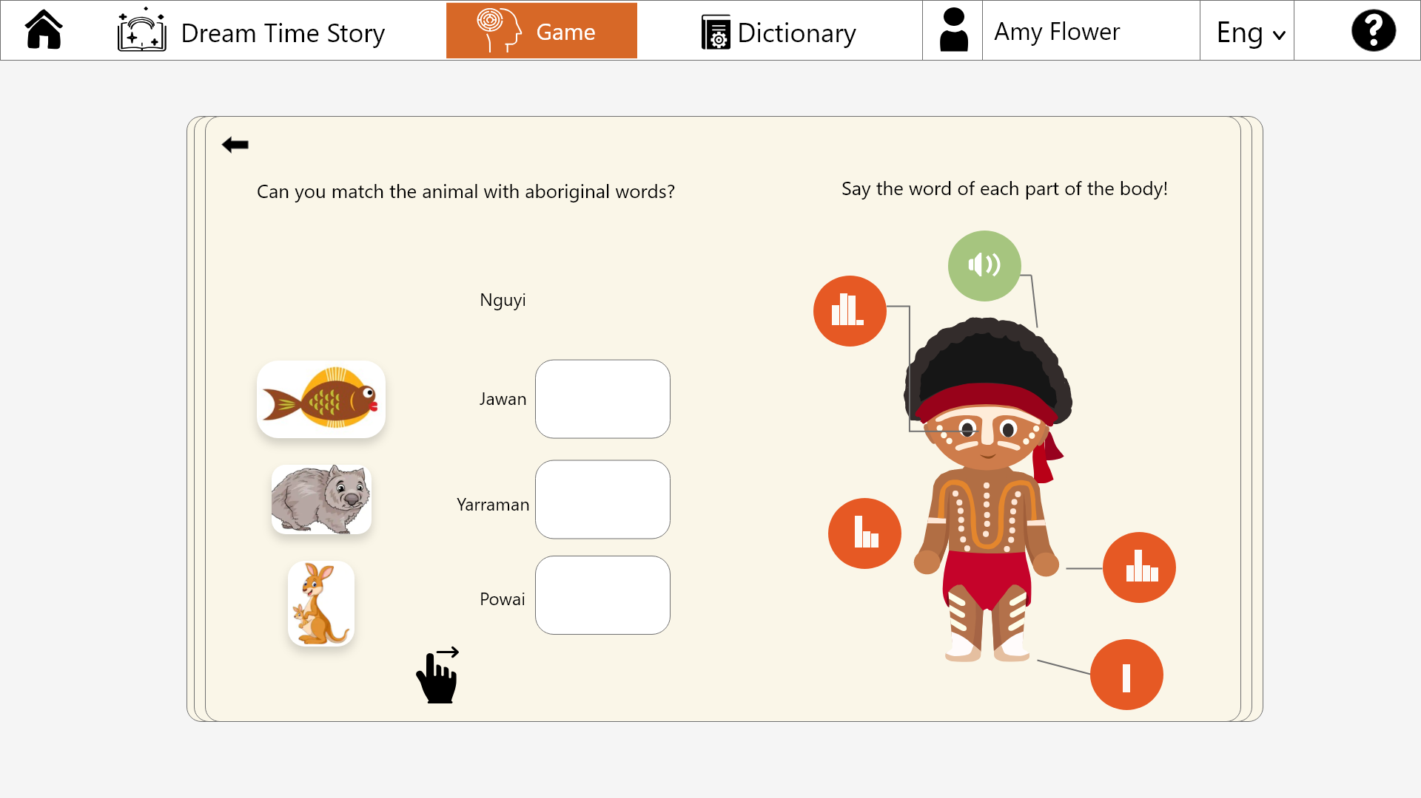

Figure 1 - game interface

Figure 1 provides an example of the kind of games that we wish to use to engage with users to teach them just a few words of an Indigenous language.

## Background Inspiration and Research

Below is a collection of websites and other resources that inspired our project and the way in which we plan to implement it particularly the way we plan to help users learn some words from Aboriginal Languages.

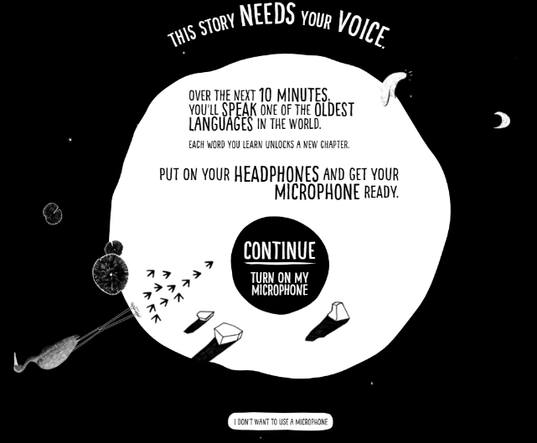My Grandmothers lingo tells the personal story of Angelina Joshua and her mission to preserve her native culture alive through language.

**https://www.sbs.com.au/mygrandmotherslingo/**

Marra the language of her grandmother is critically endangered as are 90% of Australia’s Indigenous languages.

Throughout the interactive story teaches users several Marra words such as “black crow” (WANGGARNNANGGIN) and “House” (RADBURR) through a combination of audio recordings of the words being spoken and voice-activated technology to indicate if the user has pronounced the word correctly.

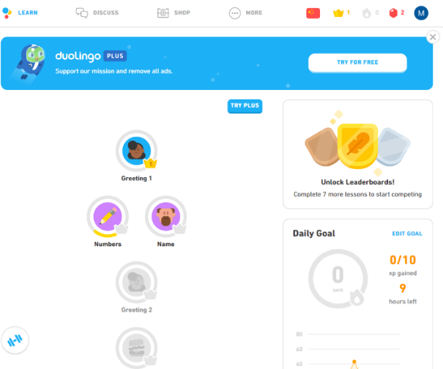Duolingo is a popular language learning site that has gamified the process of learning various languages from Mandarin to High Valyrian (from a game of thrones).

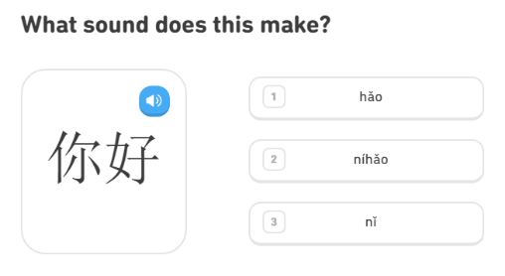This is done through goals, achievements and other rewards for completing parts of the course. They also gamify the learning itself into a multiple choice “guessing” game, If you don’t know the answer to the question you guess and are given the correct answer. This encourages people to give it a try even if they are just guessing.

A question on Duolingo

**https://www.duolingo.com**

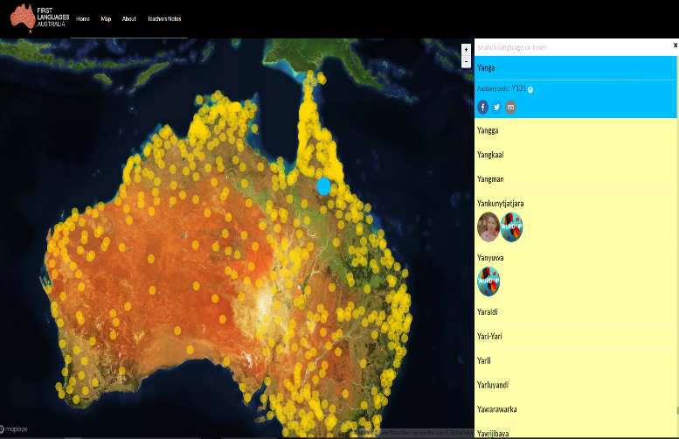 gambay.com is a website by First Languages Australia dedicated to working with regional language centres to develop a map of Australian languages that reflects the names and groupings favoured by the community.

A map similar to this would be great for our website as it would provide additional information around the language users are learning and help users to select the language, they wish to learn.

**https://gambay.com.au/map/**

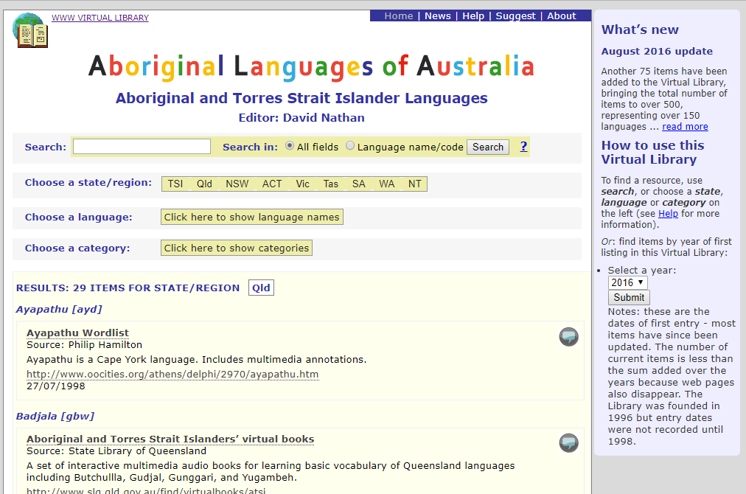Wordlists and Language resources:

A virtual library that links to several useful resources including word lists that we may use. We are as yet unsure how many languages we will support but if we move beyond those available from the State Library of Queensland (SLQ) this may provide a starting point to find particular indigenous languages.

**https://www.dnathan.com/VL/index.php?state=Qld**

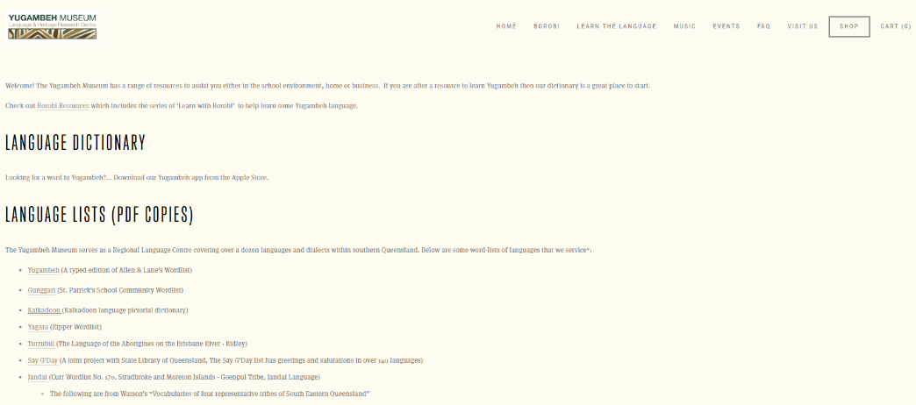Yugambeh museum that focuses on the Yugambeh language but also services other southern Queensland languages and dialects. Unfortunately, the wordlists are in PDF format which will make them time consuming to use in our project.

**https://www.yugambeh.com/learn-the-language**

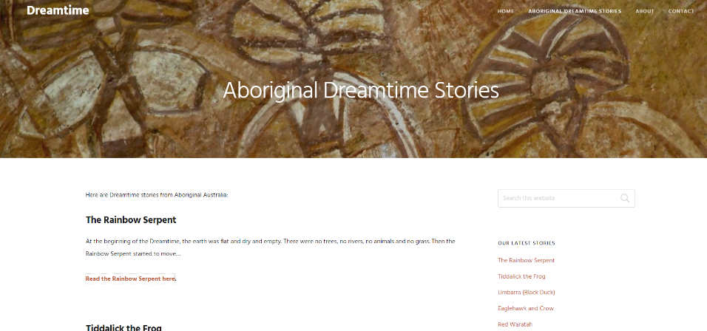Dreamtime stories:

While not our preferred resource for Dreamtime stories as not all stories have a names source or origin, some do provide a source for the story which we may use to find a more authoritative source. Additionally, these stories may be useful as placeholders in demonstrating the project.

Gamification

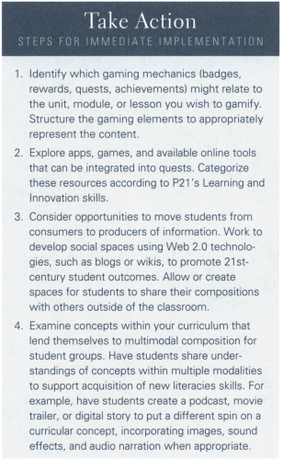Game-Based learning (GBL) is the use of video games for educational purposes and has been shown to be an effective tool to improve Learning and academic performance [1]. A new concept in GBL is Gamification which is the incorporation of GBL elements into a non-game application [2]. Gamification may include the use of such things as levels, XP or achievements to increase student’s engagement and motivation to learn.

**Recommendations from [2]**

## Features

In our application, the signature features are the games and interactive dreamtime stories which are prominently displayed in the navigation bar. In addition, there will be dictionaries incorporated into the website to allow users to look for words of interest.

Games:

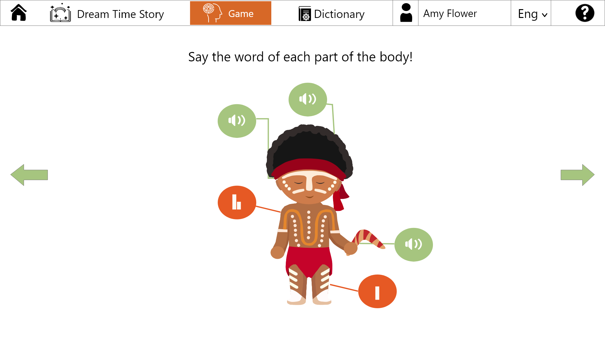

Figure 2 - Game Interface 1

The figure above shows a mock-up for our “Say Out Loud” game. There will be some options for users to play with such as language and subject. Once the user selects the language and topic, they want the application display a similar layout as above in the Indigenous language selected. This game helps users memorise words and practice pronunciation.

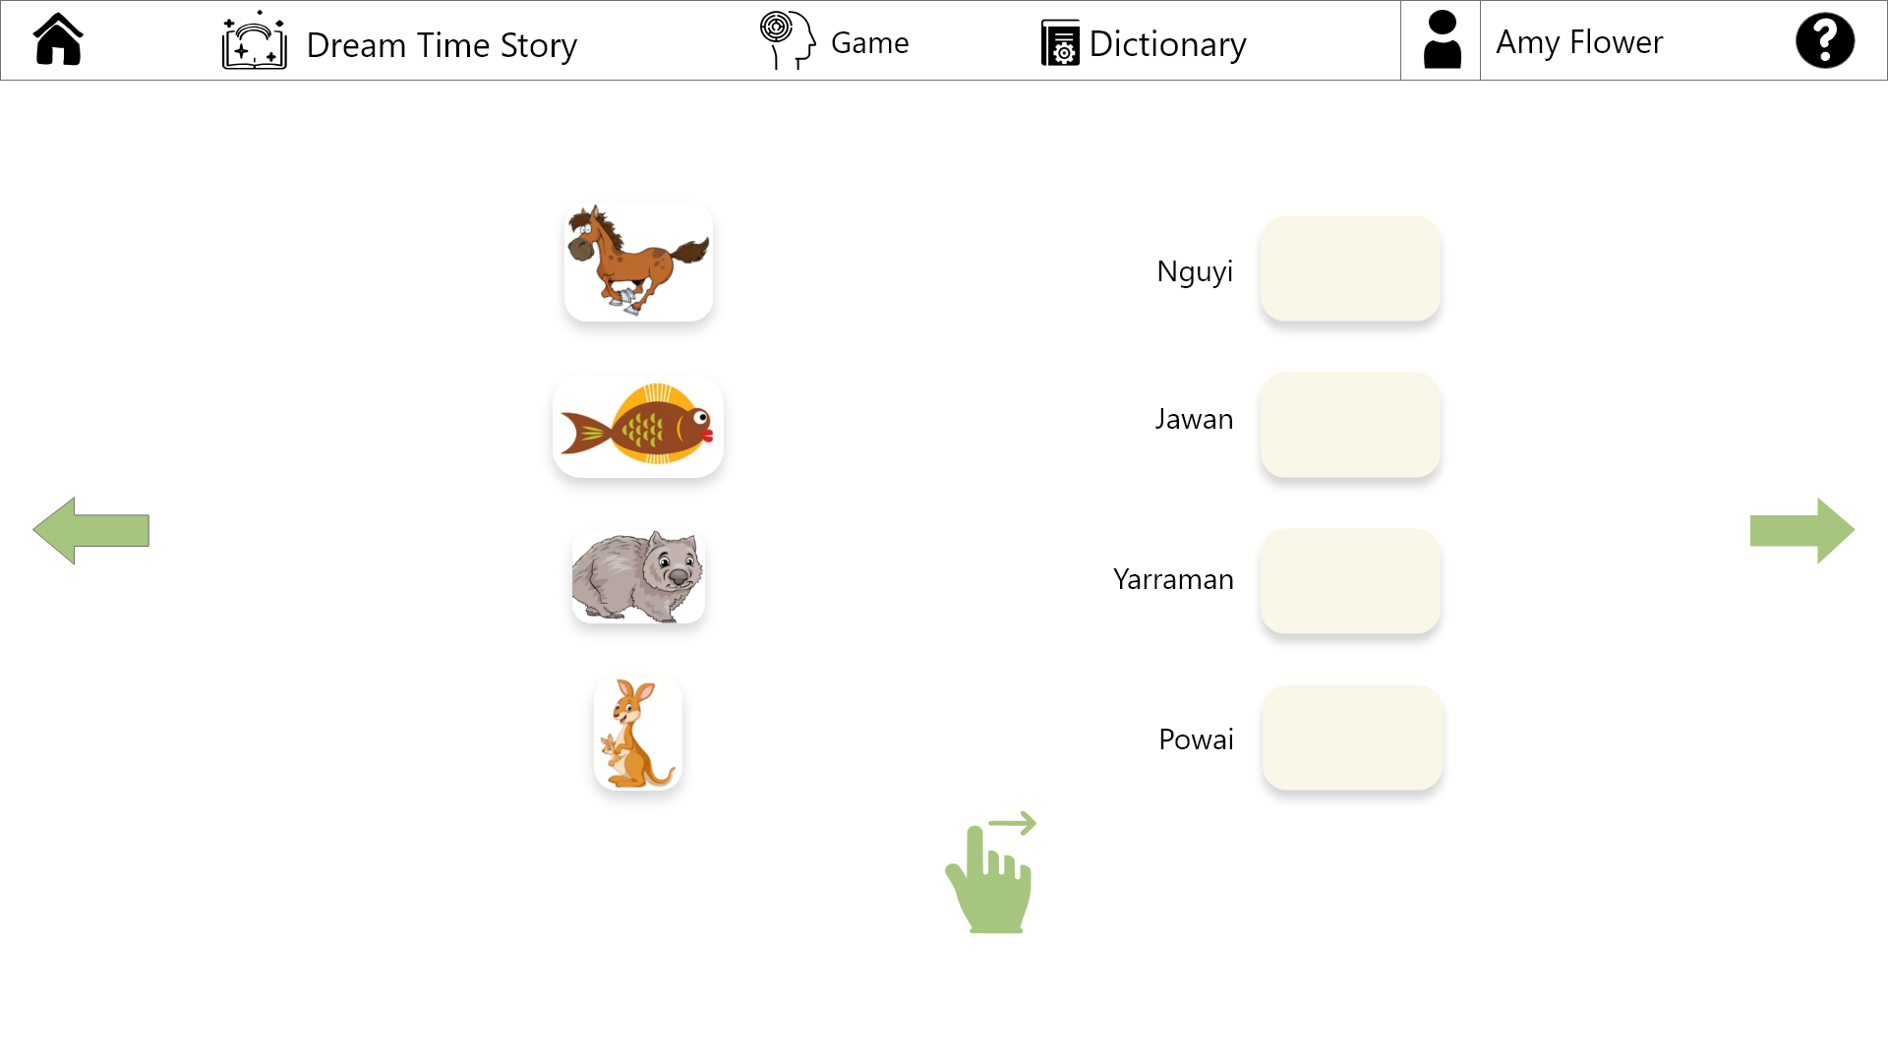

Figure 3- Game interface 2

Similarly, to the first game this game is designed to teach a few simple words by having the user guess as to the meaning of several words based around a topic such as animal names. The game was designed this way to make getting stuck in and playing as simple as possible as the user needs no prior knowledge to be able to make some guesses as to the meaning of words and the limited selection of options gives the user a reasonable change of guessing correctly which we hope will encourage users to play.

Dreamtime Stories:

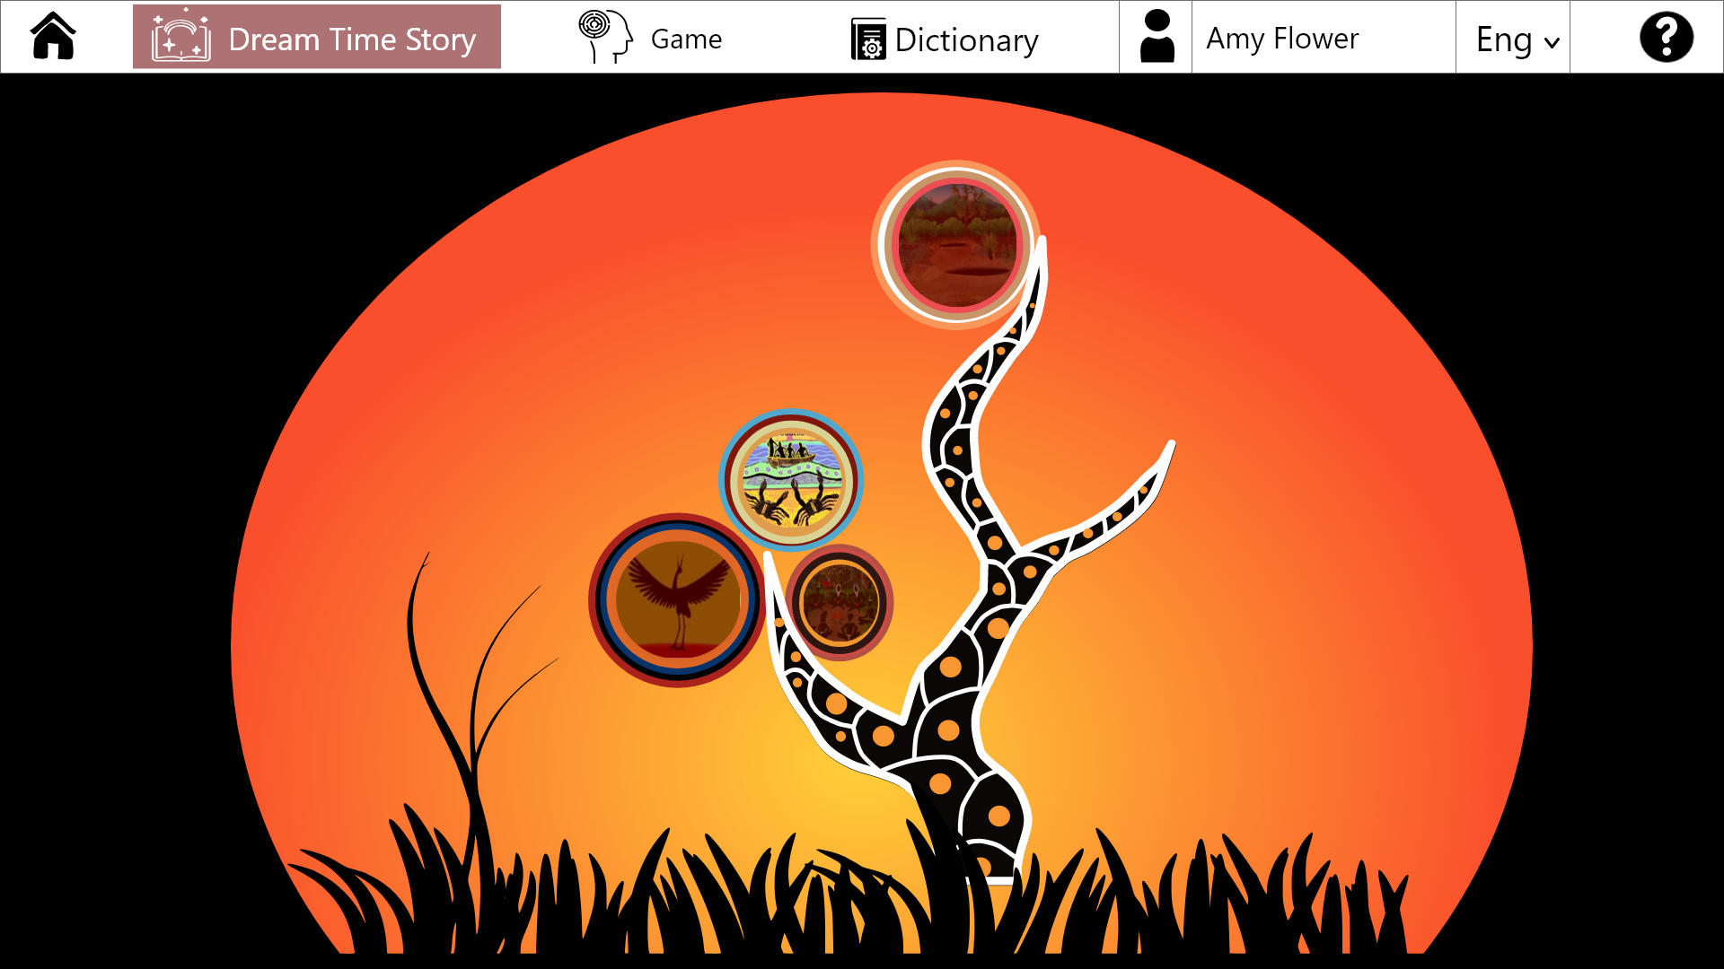

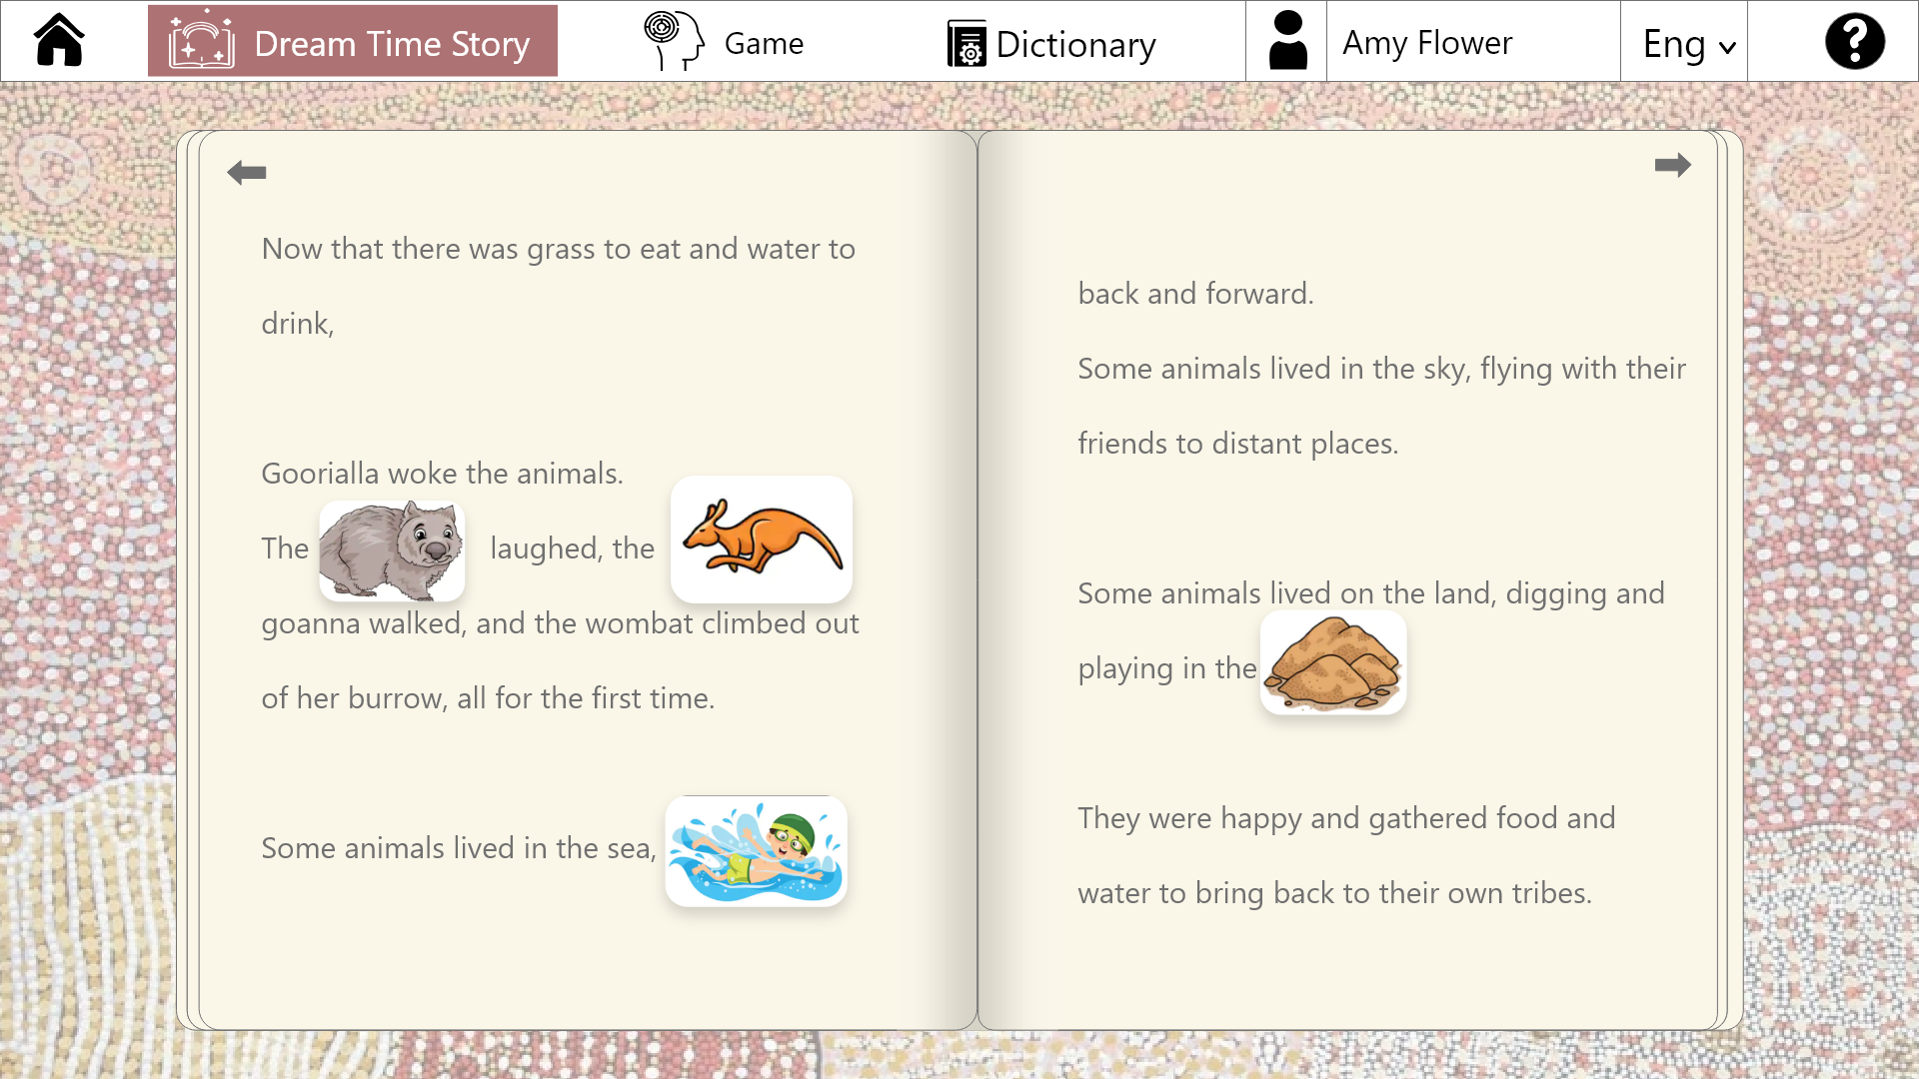 Figure 5 - dream time story

Figure 4 - Story Book

On the dreamtime story feature, as figure 4 and 5 show, we are planning to create a tree with all the Dreamtime stories relating to the selected indigenous language on it. By clicking on the associated icon in the tree the user can read a dreamtime story. Users will need to complete stories in order to move up through the tree.

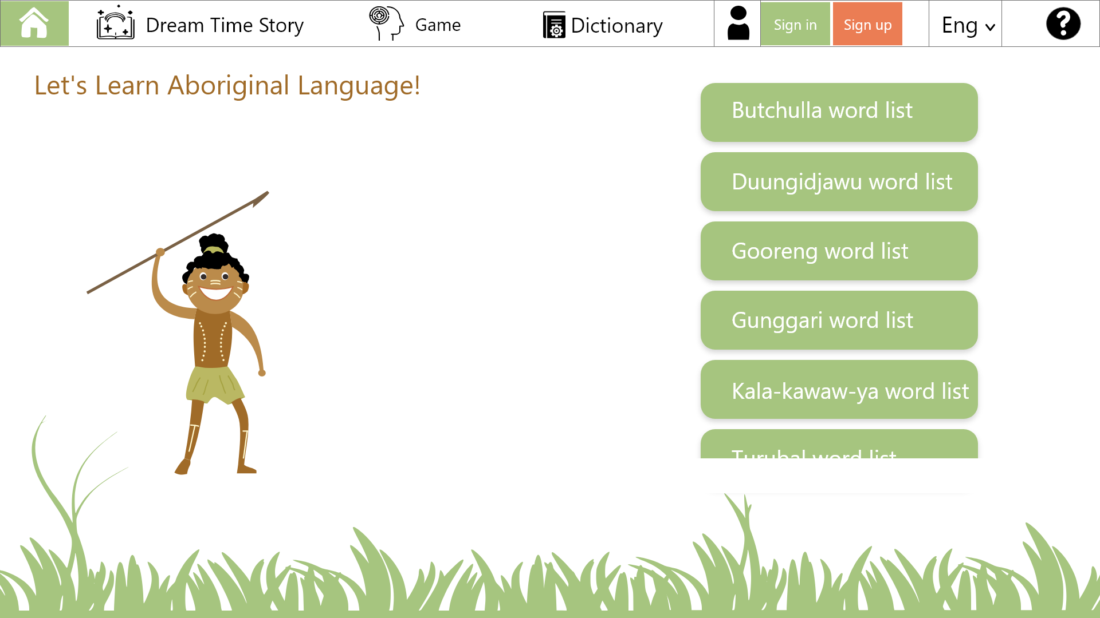

Figure 6 - homepage 1

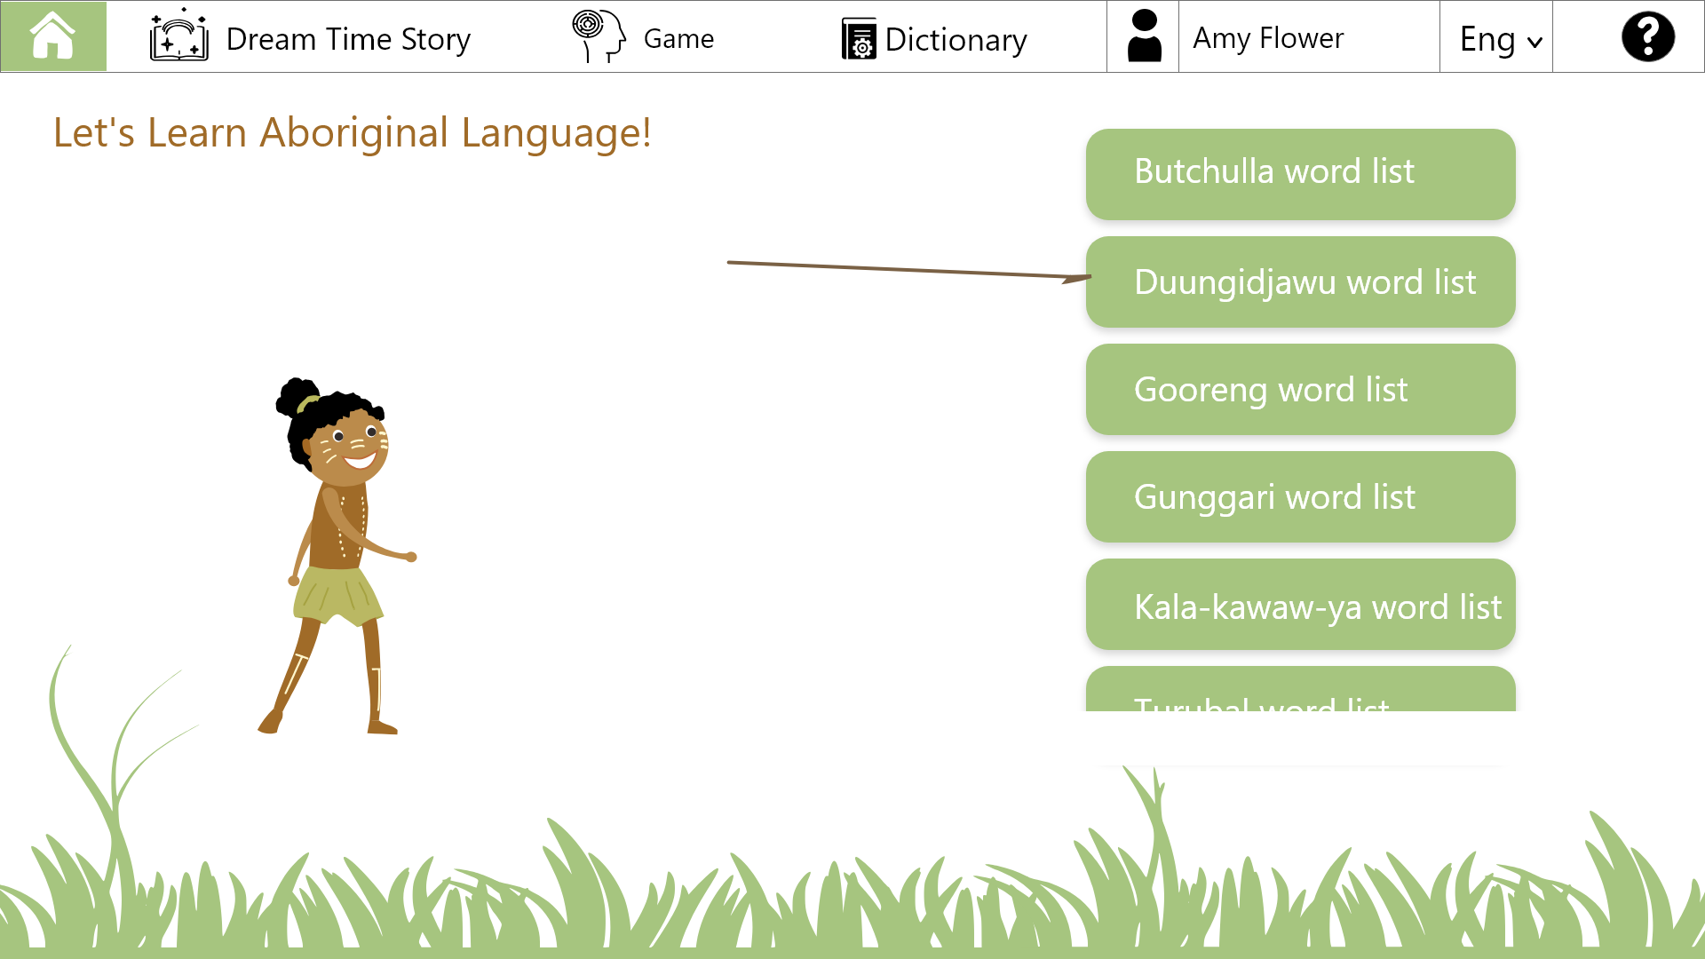

Figure 7- homepage 2

Figure 6-7 shows the layout of our home page. Since our target audiences are mainly young adults, we will keep the layout as simple as possible with plenty of colours and animations to bring the page to life. Instead of complex words to navigate with, the users can choose from a simple selection of words such as game, dictionary, etc. When you select a language a small animation of an Indigenous person throwing a spear to simulate the selection of a language.

## Target audience and Personas - Karen

## Target audience

|  |  |
| --- | --- |
| Age | 8-18 |
| Gender | both male & female |
| Language background | English speakers |
| Educational background | various from primary school level to college level based on the age |
| Regions | mostly from English speaking regions |
| Race | non-aboriginal people |
| Literacy skills | very limited to advanced |
| Background knowledge | mostly have little knowledge about aboriginal culture. |
| Outliers | Parents of some younger audience who may assist in or monitor their child’s activities |

## Analysis

The target audiences are primarily focused on non-indigenous English speakers aged from eight to eighteen.

Younger children have limited language skills. They learn languages from various sources including storybooks, educational cartoon programs, and verbal communication. They are also likely to learn from some puzzle games to improve their cognition and comprehension. Dreamtime story is designed to fit with this cognitive process, which contained images, sounds, and storylines.

Teenagers and young adults have experienced systematic language learning, who are comfortable with dictionary searching. They prefer to look up immediate and direct sources to solve the problem. The website with dictionary function is a handy tool for specific word checking.

With ubiquitously existed of different types of game in young people’s lives [4], **most** of the target audiences will be confident in playing games. And they are easily attracted by games with well-designed reward system and mechanisms**.**

**Understanding**

One of the primary methods of learning languages is through reading. The literacy skills of younger children are mostly underdeveloped, which limits their ability to read long and more complicated articles. Storybook exposure and verbal communication are two conventional and effective methods for improving their language skills and gain perceptual cognition [5].Many of their parents will intervene in their learning process by searching studying materials online or in bookstores.

Teenagers and young adults have high language level such as comprehension and are more comfortable with advanced computer interactions such as creating an account, recording or playing games. Many of them have experience of playing different types of games on electronic devices and are familiar with the unlocks, levels and reward systems in games.

Most of the audiences lack an understanding of any Australian indigenous cultures. Some of the target audience especially those from overseas areas may little knowledge about Australia.

**Demographics**

Target audiences are expected to be students aged from eight to eighteen. Considering the diversity of age, the corresponding educational level of audiences will be diverse from primary school level to college level. The target audience ranges in race and gender and overall, they are English speakers from different English-speaking countries with varying levels of understanding of Australia and Australian Aboriginal history.

Part of the younger target audience might be in the company of their parents whose educational level are likely to be higher than the target audience. These parents may participate and/or assist in the child’s interaction with our website and so must be considered in the design process. While there is no plan to place any material unsuitable for young audiences on the website, we must still be mindful of our audience’s youth and avoid topics such as cursing.

**Environment**

The web-based interaction can be displayed on both mobile devices and desktop computers. Given the plan for games and game-like functionality being displayed supporting touchscreens and dragging gestures will greatly improve the usability and appeal of the website.

**Expectations**

The website contains low-level languages (vocabulary only), which is not targeted for providing systematic language learning. It is expected that the cultural contents presented on the websites can provide target audience with enlightenment and further their interest in Indigenous culture and can expend their knowledge and understanding of Aboriginal stories, words and traditions.

The website can also become a medium of entertainment and leisure. More formal contexts, including serious history and academic findings, will not be included. Dreamtime stories, images and games will be the main carriers presenting Aboriginal words and culture-related contents, which will be easier to be accepted by young people. The reward systems for unlocking the stories and games provide audiences with feelings of entertainment and trigger them to keep learning new words and stories containing cultural information.[6]

### Personas 1

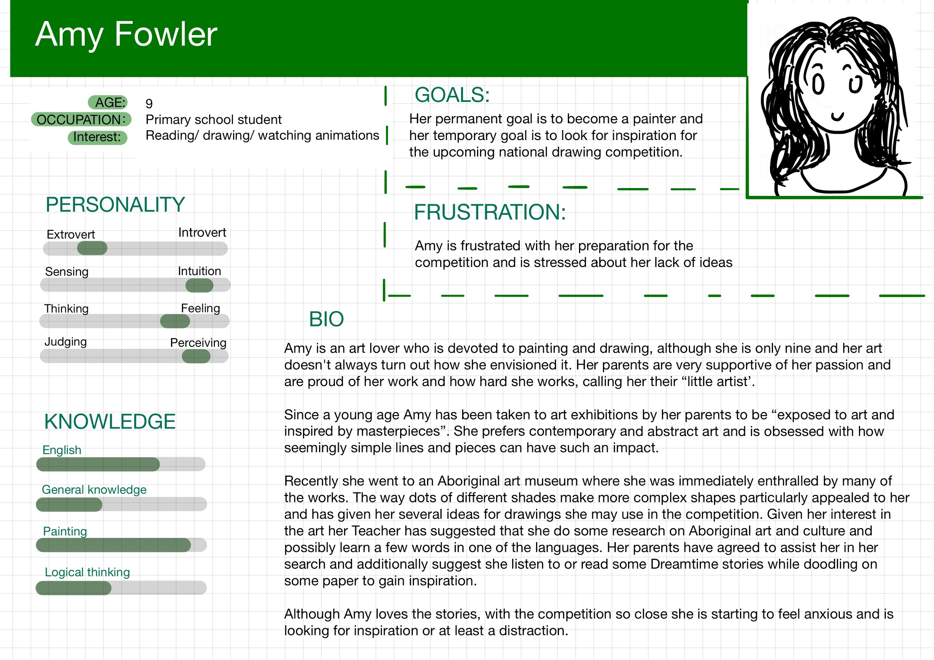

### Persona 2

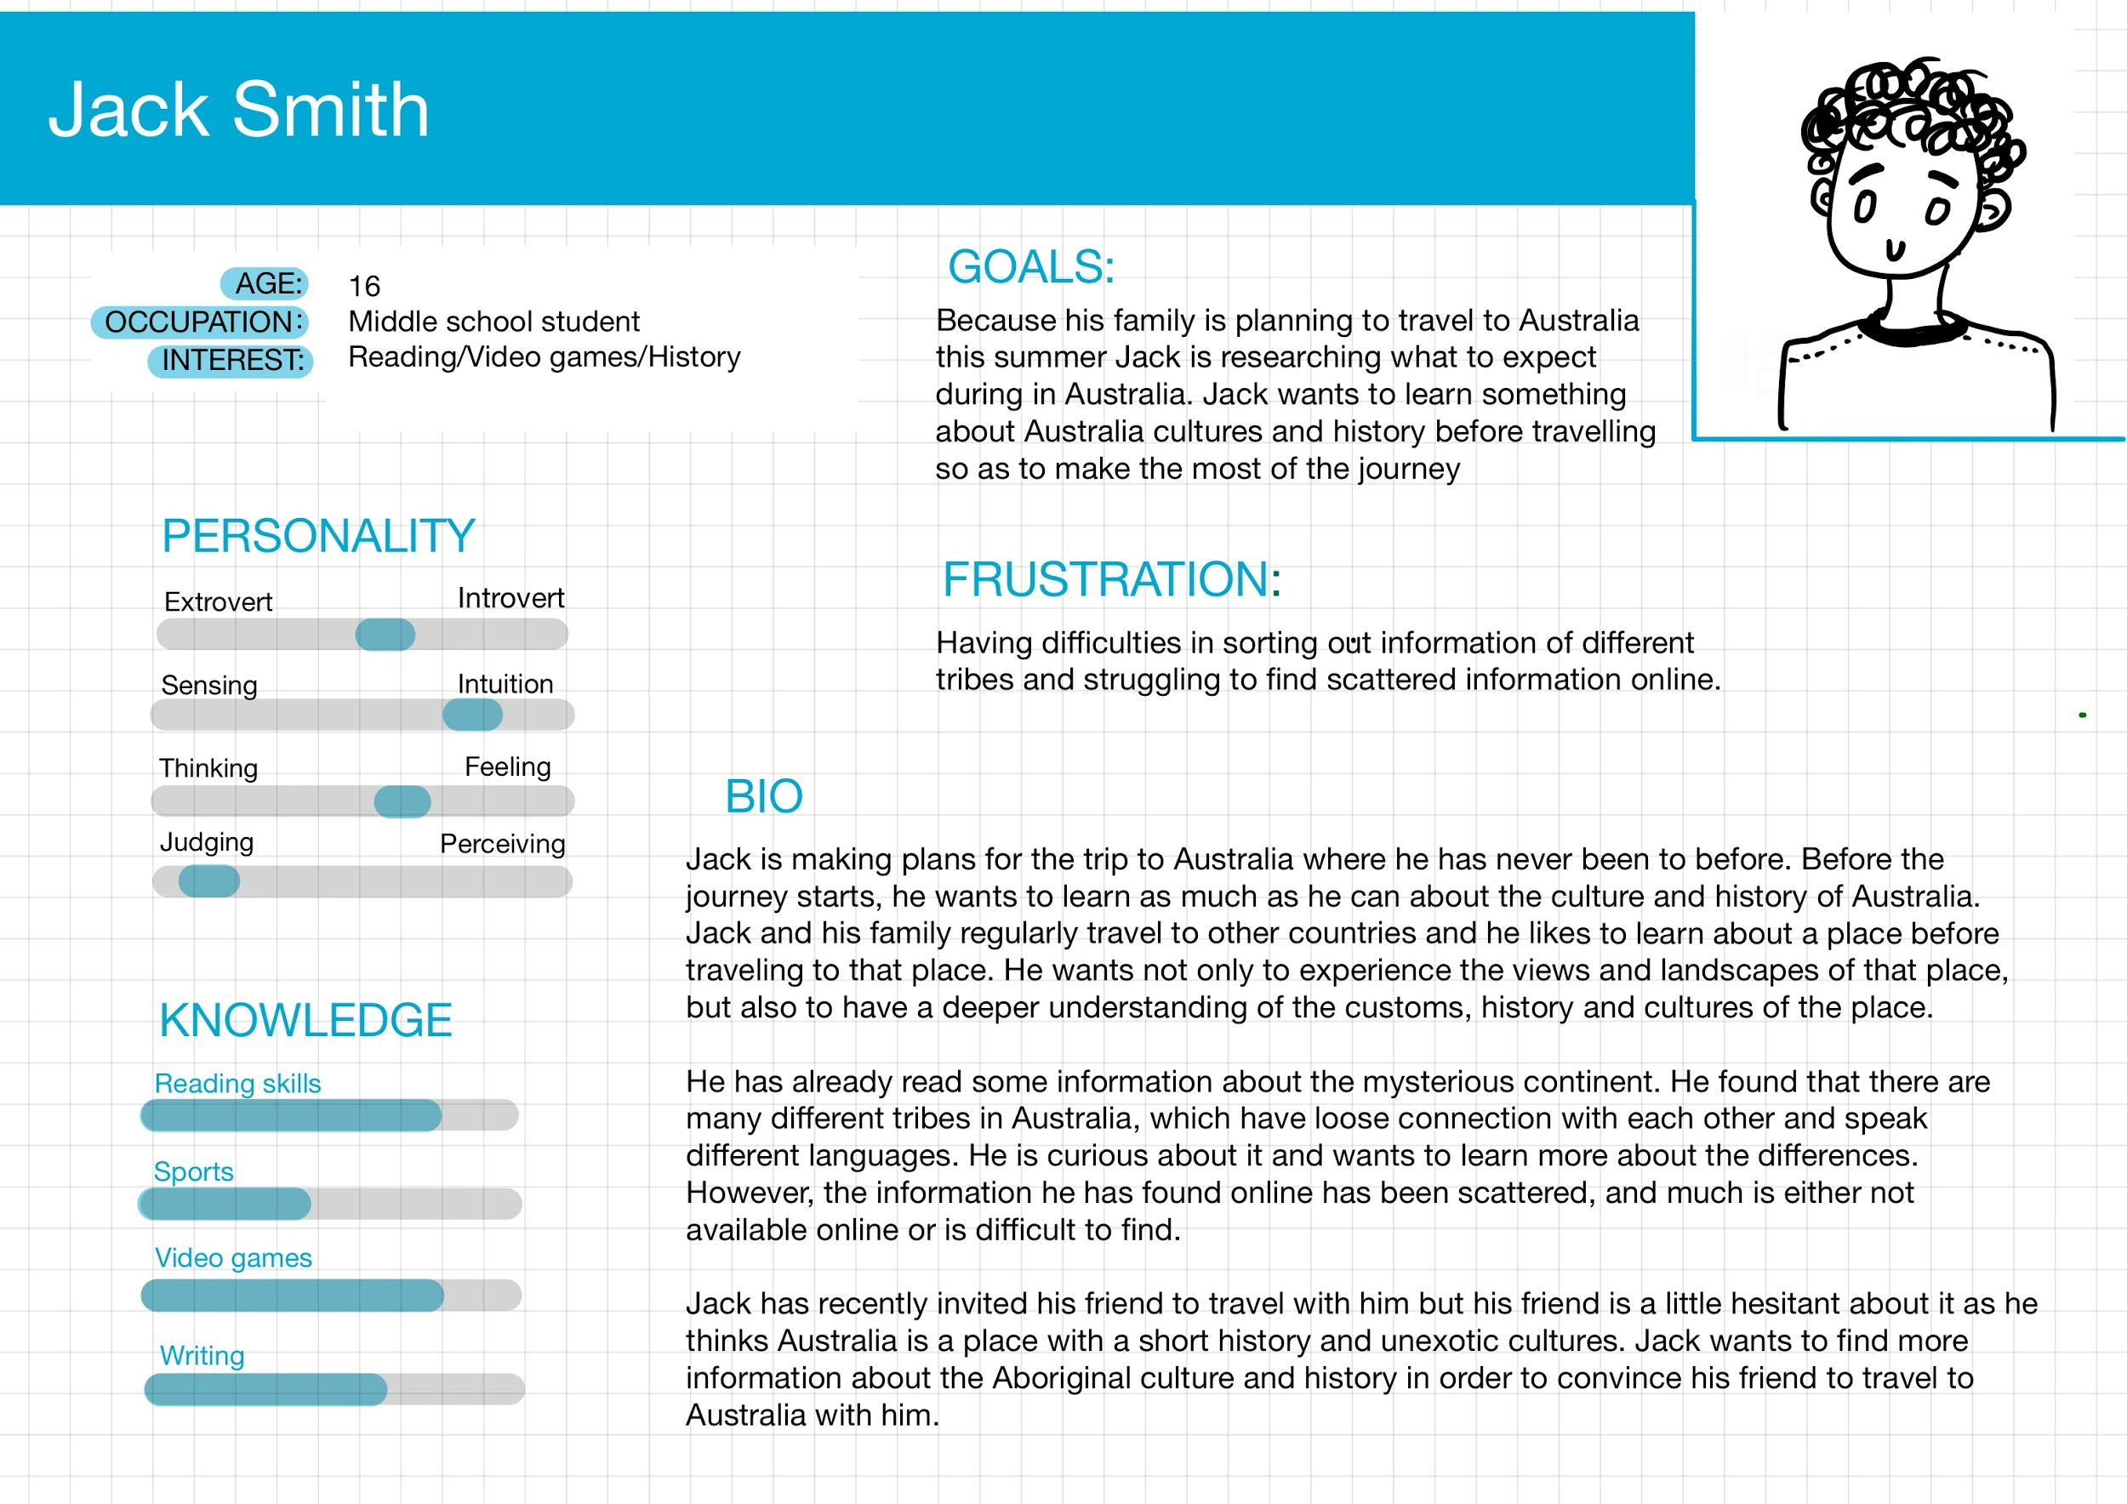

## User Experience

### Scenario 1

Amy Fowler wakes up early in the morning, it is unusual, normally her parents had to pull her out of bed to wake her up. She is excited because her parents are going to bring her to the Aboriginal art gallery in the city centre. She has been there twice, where she was inspired to create paintings based on the Aboriginal artistic form and stories. Her parents are very supportive of her interest. Last week, the gallery let out a notification that a new exhibition of several Aboriginal artworks will be on display soon. Her parents promised to bring her to the exhibition today.

After breakfast, they drive to the Aboriginal art gallery. A middle-aged commentator leads them the art gallery explaining each piece of artwork and its background story, origins, and aesthetic characteristics.

Near the reception, Amy finds a large flat screen that she has never seen before. On the screen, she saw an Aboriginal cartoon character holding a spear, with a sentence on the top: Let’s learn Aboriginal languages! On the right-hand side of the character, some Aboriginal word lists are presented. Amy is curious about the contents. She randomly chooses one of the languages, and she is amused by the character’s animation. On the top of the screen, she found several options: Dreamtime stories, games, dictionaries… She decides to read some of the Dreamtime stories. She finds that some words in the story are replaced by images. She thinks of the meaning of the images while clicking the images. The images flip over like cards with the Aboriginal words and English meaning on the back. Driven by curiosity, she clicks the horn icon beside the Aboriginal words. The sound of the pronunciation is loud enough to attract the attention of the staff around.

“Oh, it’s a new interactive exhibit we recently implemented. It is a website that teaches children such as yourself, some Aboriginal words through stories and games. You can interact with it in many different ways. See, in the game section, you can drag the images to match the Aboriginal words, you can say out loud the different words of different body parts, you can also unlock new stories if you finish reading this one. It has been a real hit with our younger patrons such as yourself.” One of the staff kindly explains to Amy.

Amy successfully unlocks the next stories, and she wants to read more. However, her parents tell her that it is time to go home. Amy feels reluctant and begs her parents to stay longer. The staff member laughs and says, “don’t worry, you can access the website at home on any electric devices. You can also create your own account for recording your progress.” Amy gets the link for the website and leaves with satisfaction. She decides to keep playing with the site as soon as she comes home.

## 

### Scenario 2

Jack Smith is planning to travel to Australia during this summer vacation. He has never been to Australia. He imagines it as a place covered with dangerous animals and barren land. He has been planning the trip for a few days. After searching for some relevant information, he finds the amateur of historian and culture buff fascinated by the Aboriginal culture and want to learn more.

He turns on his laptop and considers joining some one-day Aboriginal tours during his stay. He searches for travel logs written by others who visited recently and expects to find some suggestions. One of the travel logs he finds mentions an intriguing website, with a link named: learn Aboriginal languages. “Sounds interesting, there is no harm in learning a few Aboriginal words for traveling. I can also show it off to my friend Tim.” he thinks.

Jack clicks the link, which leads him to the website page. He looks at the homepage of the website, “it’s cute,” he thinks. Without knowing anything about these words in the word list, He randomly chooses one, and the website displays his selected language on the top right corner. Jack notices the options on the navigation bar: Home/Dreamtime stories/Games/Dictionary/Sign-in/Sign-up/Help. He is immediately attracted by the game option. He browses the games and chooses “Speak Out Loud”. The browser asks for his permission to access his microphone. He confirms it and is ready to explore the game. However, he is frustrated to find out that he knows nothing about the Aboriginal words displayed on the screen. He decides to quit the game and move onto something else. He then clicks the dictionary next in hopes of finding answers. He searches the body part in English, as expected, the English words with the relevant Aboriginal words are shown. He also surprisingly finds out that the pronunciation of the Aboriginal words also contained. Jack clicks one of the words and listen to the pronunciation and memorises them. He returns to the game page and tries to pronounce the Aboriginal words. To his delight, his pronunciation is checked to be correct, and the character moves.

After many attempts, Jack memorises a few words and successfully unlocks several levels of the game. He is fascinated by the interesting game design of the website. Meanwhile, he finds the dictionary function is quite useful for looking up new words and is easily accessible. He saves the web page in favourites. When he is about to close the webpage, an alarm pops up and asks if he wants to keep the game progress, he chooses “yes” which triggers the page to the account register/sign-in page. He uses the sign up to quickly registers for a new account.

Jack opens his Messenger and decides to send the link to his friend Tim. He wants to persuade Tim to travel with him. Therefore, he hopes the webpage plus other information about Australia will motivate Tim to join him.

### Story board

Storyboard 1

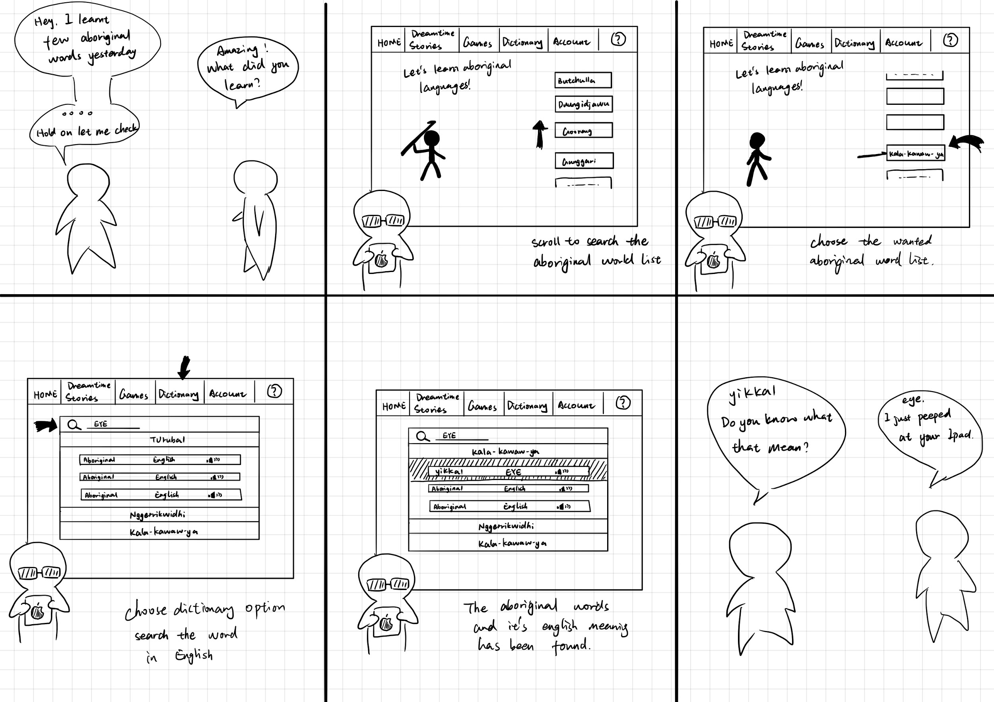

Storyboard 2

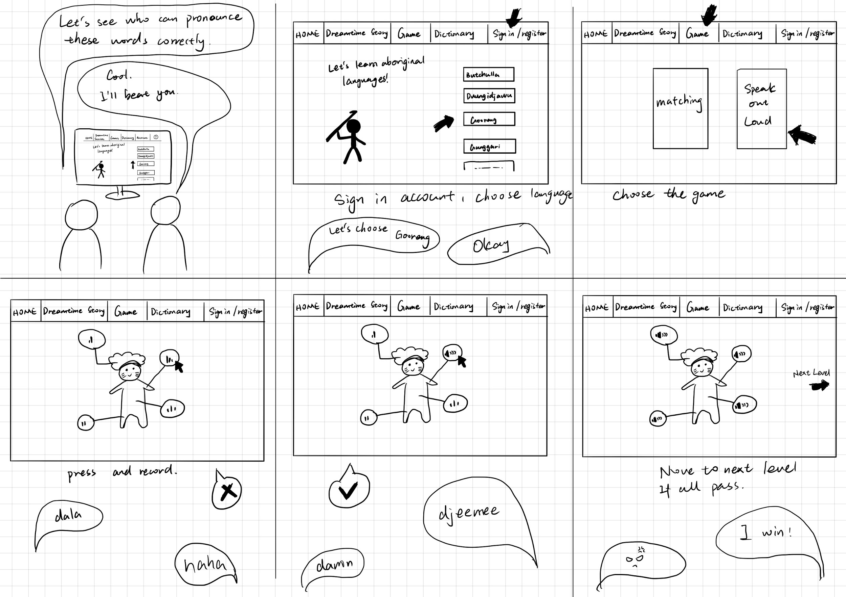

### Site Map

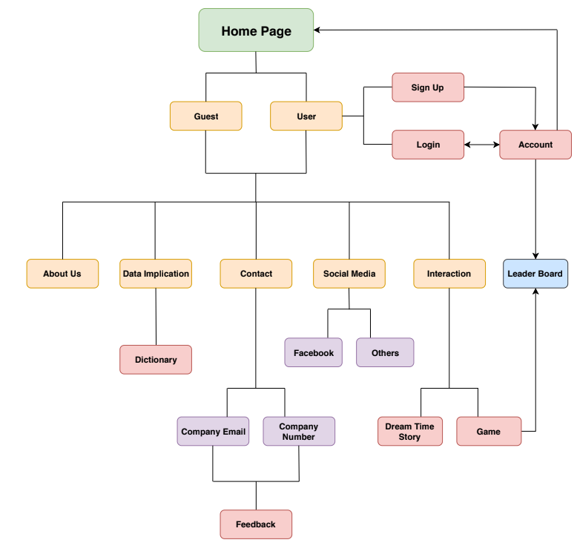

### Wireframe

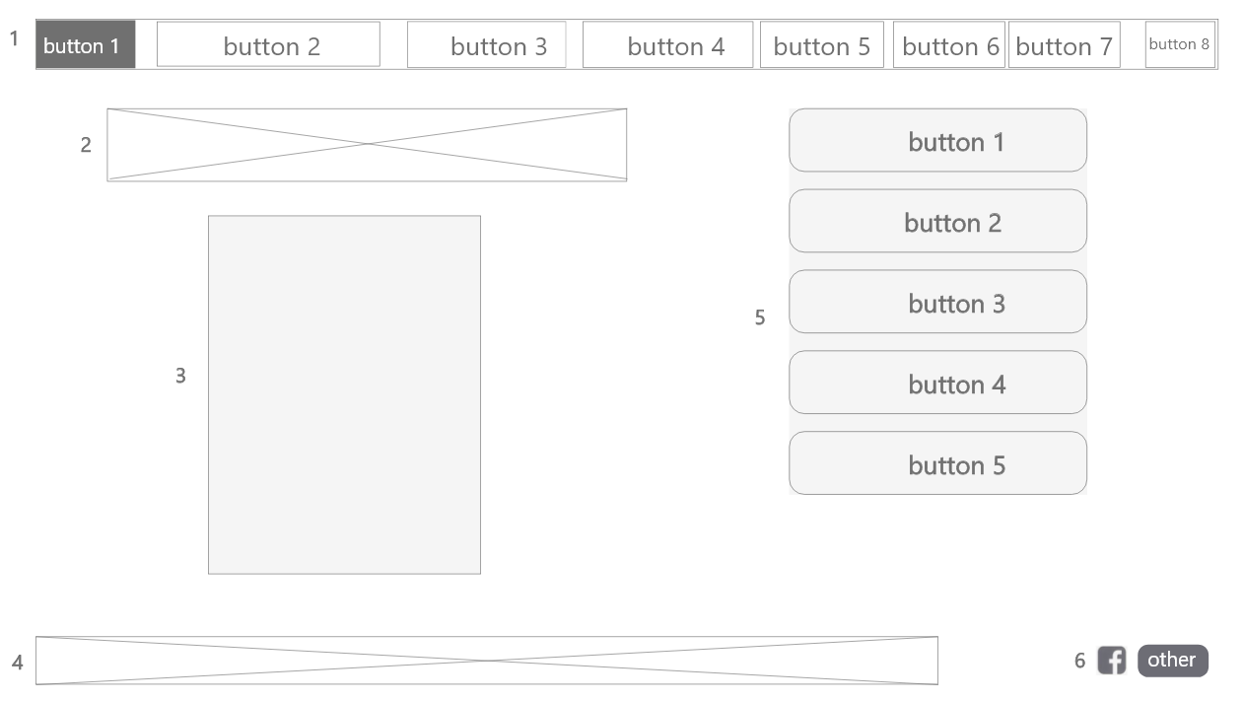

1. Main navigation bar with buttons linking to other pages of the site: Home page - Dreamtime Story - Game - Dictionary - Account/Profile - Language - Contact Us - Help
2. Main title of the homepage
3. The animated character
4. Developers information
5. Buttons to choose different aboriginal languages to be displayed on the website
6. Share functions that link to popular social media.

## Mock-up

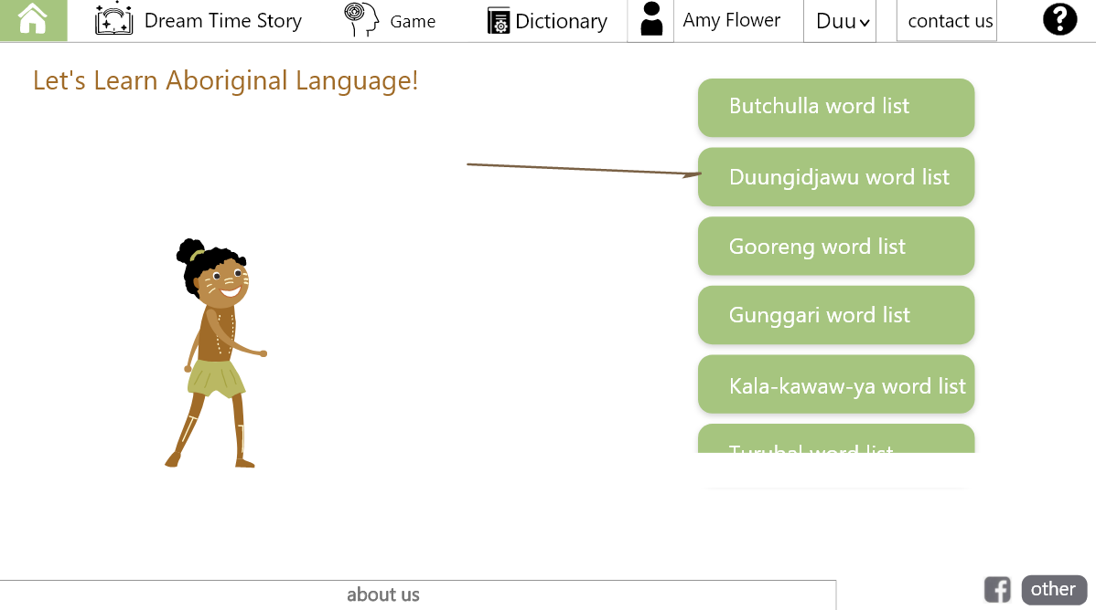

## Datasets and Database

The project will be using several data sources that we plan to combine into a single database. To assist in managing the data and to help with scalability the different datasets are:

1. Wordlists
2. Dreamtime stories
3. User profiles

## Wordlists

The wordlist we plan to use are from the State Library of Queensland (SLQ) and can be found at [https://www.data.qld.gov.au/dataset/slq-Aboriginal-languages-word-lists](https://www.data.qld.gov.au/dataset/slq-aboriginal-languages-word-lists). Most of these wordlists are available via API but some are only available as a downloadable CSV. Additionally, the fields available in the datasets differ somewhat from dataset to dataset. Fields such as phonetic spelling are sometimes included, and some include multiple languages across separate fields.

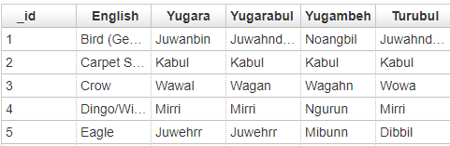

**Example 1 Animal wordlist**

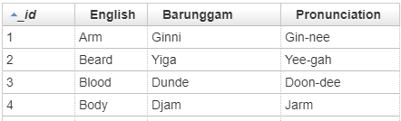

**Example 2 - Barunggam word list**

Wordlists are also available in pdf format from other sources, but these are unlikely to be used as we have enough material available from SLQ that is in a more usable form.

Ideally for each word we would have:

* Word (spelled using English alphabet)
* Meaning in English
* Phonetic spelling
* Language (which Indigenous Language the word is from)

### Dreamtime Stories

Currently our only source for dreamtime stories are websites which is far from ideal. Ideally, we would contact an Elder or multiple Elders and request stories and permission to include their them in our project but this may not be achievable due to time constraints in particular for the demonstration.

Ideally for each story we would have:

* Title
* Text (possibly with html mark-up for easy insertion into the website)
* Origin (the people the story comes from)
* Language (the language the story has been translated from)

### User Profiles

Each user of our website will have a unique account with a password this will be used to track levels, achievements, unlocks and any other game elements or any setting for the account.

For each user we plan to store at least the following points:

* Username
* Password (preferably stored securely)
* Progression (levels, unlocks, etc)
* Email address

### API’s

At this stage we will use the API data to update our own database of words as our dictionaries will come from a few sources. This is to simplify the word processing for stories and games.

### Database

At this stage the team is planning to use an SQL based database therefore we have come up with the following preliminary ER diagram:

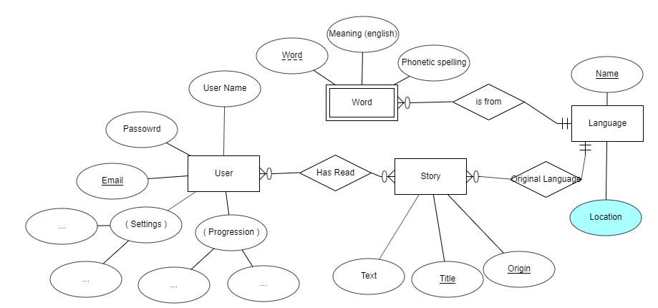

# The Team

Below is a short biography of each team member outlining the skills they bring to the project as well as personal goals or skills they hope to achieve by the end of the design project.

## 

## Kieran Quirke-Brown(team leader)

I am currently studying a masters of information technology while working full time at Schneider Electric working as a smart services engineer. Based on my past university courses, university projects and work I believe my top skills that I bring to the project are: project management, front end programming and server side programming. I have little design experience and hope to build some skills in design by creating some of the pictures and graphics within our website.

## Mark Bird

I am currently studying a masters of information technology, my background is in mathematics but I have also studies Databases, programming and some web development. I have limited design experience which I hope to expand upon but will be best utilized working on programming and database tasks

## Mengqi Huang

As a member with design background, I enjoy applying my design skills to solve real-world problems and being part of the creative project. Based on the previous project experience, I can bring the following skills to the team: aesthetic designing and front-end developing. I have no experience in back-end developing and hopefully I am able to expand my skill sets through the project.

## Zhi Zeng

I am currently studying a Master of Information Technology. My background is business; however, I have studied some web design including JavaScript, HTML, CSS. I currently work part-time in marketing and design, but I feel like there is still so much more to learn in terms of web design and web development. I hope that my current knowledge will help me complete the tasks set by the team.

# **Design considerations**

The team recognises topics involving Aboriginal and Torre Strait islanders has not always been approached in the best or most appropriate manner. In an effort to avoid this situation the team hopes to consult with Aboriginal elders with regards to culturally appropriate traditions and teaching styles. While the team will make the best efforts for this to happen, we realise that the time frame is limited, and people may be unavailable. Therefore, failing to make contact the team will research things like stories related to a group of people and use that story for the language learning process. This is to avoid cultural insensitivities when using a few stories to cover all the Indigenous languages as the Indigenous group may have no cultural connection to a particular story.

Furthermore, we acknowledge that as developers we may design the application in a particular way as we feel that is the best approach however this may not be the case for the target users. In order to ensure the application appeals to our target audience we will get people who fall into our target audience to try out the application and provide feedback so we can improve upon it.

The final challenge the team will face is sticking to the timeline and not over focusing on one particular feature. In order to achieve our goals, we will break the tasks into short manageable piece and work using an agile framework. This will allow us to review tasks and foresee any difficulties associated with the task to determine if further time should be used to overcome the difficulty or take another approach if possible.

# **Design process**

## Development style

At the beginning of this project the team decided to assign each task to an individual who was ultimately responsible for its completion, including seeking help from others or researching solutions to a particular problem. Where possible a single person was responsible for an entire webpage to minimise complications from integrating work from multiple sources. This compartmentalised approach along with weekly meetings and regular slack conversations had both benefits and drawbacks.

Benefits:

* Allowed for flexibility as everyone could work to their own schedule so long as they met deadlines.
* Challenged Team members to learn even when they sought help from others, they usually ended up finding an appropriate solution.
* Supported cooperation and coordination without excessive meetings.
* Almost no problems with version control with only 1 easily fixed problem (this was greatly helped by GitHub).
* No integration problems.
* Work could be assessed more objectively by uninvolved team members.

Drawbacks:

* Time was lost learning skills for tasks that another team member already possessed.
* Styling needed to be redone to make the website look more uniform and consistent instead of a jumble of independent parts (and in some cases due to time constraints could not be fully integrated into the team’s styles sheet).
* Some tasks likely could have been done better by other team members.
* Some team members who were less confident in using the zone chose to work locally in HTML which then needed to be converted and uploaded to the zone.

In our opinion the benefits of this development style outweighed the drawbacks, and this seems to have worked well for our group with steady progress being made throughout the project and team members both seeking and offering help/improvements when they felt there was a need.

## Challenges

Throughout the project multiple issues and challenges arose that needed to be overcome by our team. Many of the issues where minor and easily solved such as creating and connecting to a database hosted on the team zone. Others where more challenging such as integrating words from Aboriginal languages into a dreamtime stories elegantly or producing a map with the rough locations of various Aboriginal languages. Our challenges can be separated into 3 separate groups, Design challenges, Technical challenges and Time constraints.

Design challenges:

* Our biggest design challenge was the user interface around the stories and game.
  + For the story’s user testing showed that users didn’t understand how to turn the pages. Users were required to turn pages by clicking on the corners of the page as if you were turning the page of a physical book. To overcome this issue, we added an animated arrow to visually show where users should interact with the book.
  + Game users didn’t initially understand what they were supposed to do when with the word matching game. This issue was alleviated by adding some text that instructed users where the words needed to go more prominently.

 Technical challenges:

* Database
  + Although ultimately easier than expected due to how the zone was set up hosting a database and accessing it via php was a new experience. The ease with which we were able to connect to the database via php and run SQL scripts gave the team the ability to implement dynamic content where the MVP called for simulated content such different language selection for the word guessing game.
* Animation
  + While some of the team had limited experience in simple animation from DECO7140 our design for an animation involving the throwing of a spear into the button the user collected initially proved problematic and its implementation was delayed and ultimately simplified.
* Game mechanics
  + Initially the plan was to have the user draw a line or otherwise connect an image to the word as seen in the mock-ups. However this proved difficult to implement and after consulting with a tutor and doing additional research an alternative approach was developed using jQuery UI functionality to allow the word (specifically the *li* container) to be dragged and dropped onto a *div* containing the corresponding image and in the case of a mismatch the word reverts to its original location.
* Map
  + While our initial proposal mentioned a language map as a stretch goal it was initially thought unachievable because of initial research didn’t result in a practical alternative to google maps which we were unwilling to use due to the pricing and credit card requirements. This problem was solved for us by the course itself that included a tutorial for a free open source mapping library called OpenStreetMap and leaflet which demonstrated how to implement our idea and while the map remained a low priority item it was included in the final product.

Time Challenges:

Probably the biggest challenge we faced in this project is the strict timeline and to meet this challenge we prioritised the various features/tasks so that we focused our time and effort on what was most important to the project and didn’t waste time half completing various features that may or may not be completed by the deadline. As the project progressed and the team gained a better understanding of what could and could not be achieved within the time frame the prioritised item list was altered and refined.

## Feedback

Feedback was taken from two main sources during the Part B demonstration and relatives that fit within the target audience of our application. We requested specific feedback from users after they had gone through the demo. This involved discussion with the user as they interacted with the website and guidance from a team member when needed. Following this demo, the users where asked specific questions about how they felt about the project with a focus on interaction and the interface (See appendix A for the questionnaire).  Following this process, the team prepared a Feedback summary covering each question and general feedback from users (see appendix B). After this we prepared an informal response to the feedback (see appendix C).

The feedback we requested covered 3 broad areas with an additional question for any other ideas/suggestions the user had.

1. Content
   * This was generally about what the users wanted out of the website and what features they felt were the most important .
2. UI
   * Did they have any problems interacting with the website and was their anything missing or any interaction they could be done better.
3. Style
   * Did they like the overall look and feel of the website, was everything easily readable, did they like the colour scheme.

Generally speaking, the feedback was positive in regard to the idea and content but was critical of the UI with users lacking direction and unsure how to proceed.

Changes in response to feedback

As a result of the feedback several changes were made to the design:

1. Double clicks were changed to single clicks.
2. Visual clues as to how to turn the pages of the story were added.
3. The instructions for the game where moved to a more prominent location.
4. The game was reworked to only include words from a single language at a time. This also required a redesign of the layout as with only 3 words and 3 images the page was very sparse and so additional words and images where added to the game to bring the word count back up to 6 with additional pictures.
5. The images used in the game where modified to look like those in the storybook with rounded edges for consistency and aesthetic reasons.
6. The words on the back of flip cards in the stories were repositioned to bring them more in line with the text of the story.
7. The story we proofread for grammatical errors.
8. The story close button was changed to a tree to make it clearer that it returns to the story selection page.

Additional changes made not in response to feedback

1. The game was redesigned due to technical challenges as discussed previously.
2. The Map was integrated into the website when we discovered an easy implementation through practicals, although with a limited number of language locations marked. This was due to time constraints and the feature being a lower priority.
3. The Animation on the home page was left for later in the project and then simplified.

# Design Implementation

Our final product has implemented all the core features mentioned above as well as one of the stretch items, namely the map. Our website can be broken down into 4 main interactive pages and 4 other critical pages with different levels of functionality. The following sections give an overview of technologies used in the website as a whole and then a description of each of the pages.

The website sites on the team zone provided by UQ running a NGINX web server. We tried to follow a model, view, controller framework to keep the files neat, organised and logical where possible. Additionally, we included an archived file to move any older files that were no longer required but may be needed for reference. The main technologies to develop the website include the standard front-end languages, html, CSS and JavaScript/jQuery and used php for the back-end control and navigation between pages. In most cases we were able to keep styling separated from the content of the pages through an external source for CSS, however some development occurred in html pages which then needed to be ported across to php pages. During this integration of pages, we ran into some styling issues which lead to some pages including their own CSS styling, aside from this we used some in line styling for critical styles. Users can navigate through the various features using the navigation bar which bolds the text to let you know what page you are currently on. To make the website more responsive we used the open source bootstrap framework so that the application could be used on phones or tablets. This was to reach as large a target audience as possible as we recognise that some users like to do things on the go so keeping responsive was key. For the backend data storage, we used MySQL for data storage and phpMyAdmin for managing this database.

The first main page implemented was the story book which presented an aesthetically pleasing format in the form of a book to read traditional dreamtime stories. The users will need to turn pages to read through each story flipping cards over to find out what each picture means and the Aboriginal word for it. This functionality was implemented using turn.js which is another open source JavaScript library used to create animated books. Using this library with some personal styling the team was able to create a nice flip book that looked and felt at one with the website layout. We made an effort to match the language used on the flip cards with the group the story originated from, but we are by no means experts in this area. User progression has been simulated in this aspect of the website. When users finish reading a book and exit, a new book will be found in the tree to read. This was done to simulate what we would do if we had a true user levelling system.

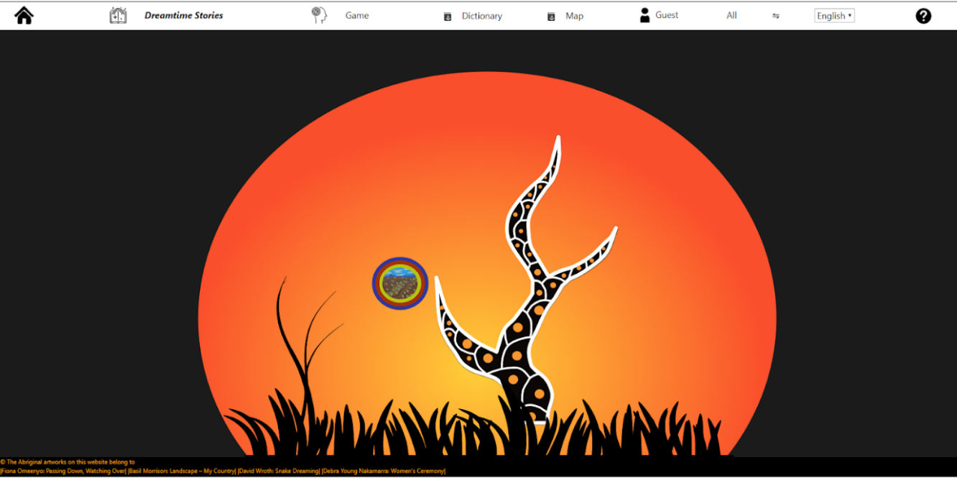

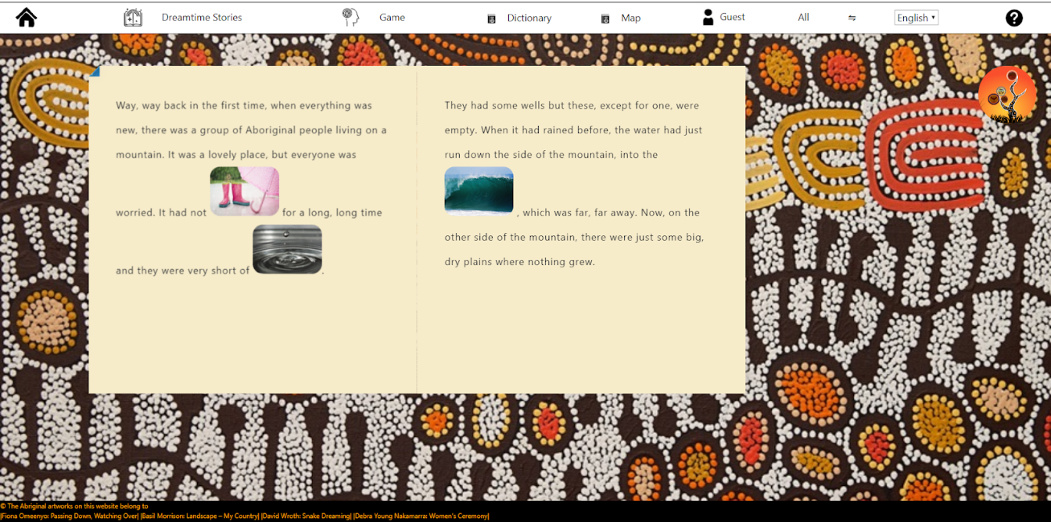

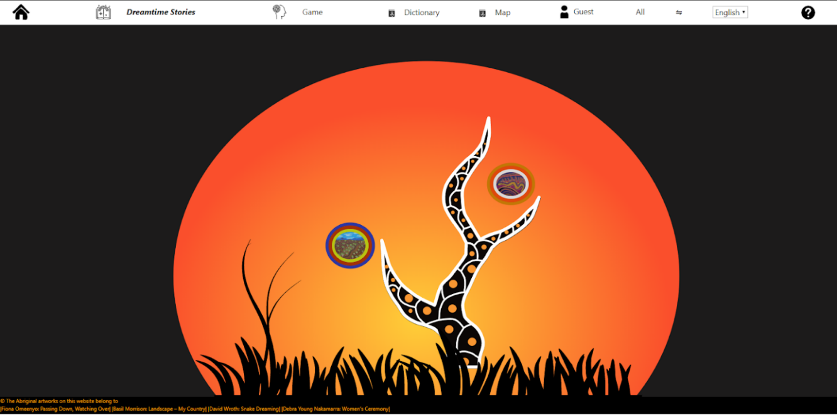

The next main page was the game where users were required to match words to a corresponding picture. Users will grab a word from the list and drag them to the correct picture. If the word is matched correctly it will stick to the picture and turn green, otherwise it will return to the word list. Once all the words have been matched an alert will show up on the screen to congratulate the user. The game was implemented using some creative JavaScript/jQuery to move the words and dynamically change the page while php was used for word selection based on a filter in the upper left corner. While there is a limited number of languages to choose from the page itself has been almost fully implemented with the only simulated element being the option to replace the topic of animals with greetings which will have no effect when selected.

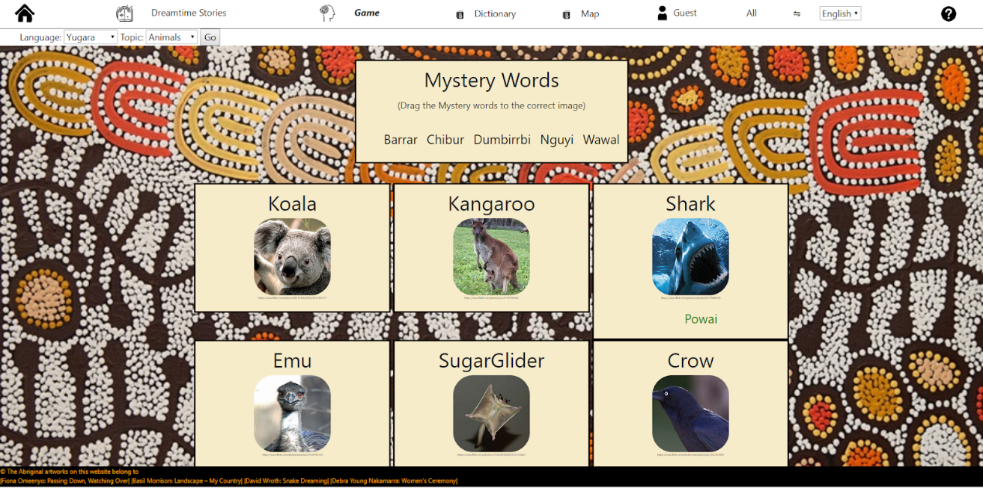

Following the game page is the dictionary page which is built upon php for database interaction and to dynamically update the page based on filtered words/language. Users can go through the dictionary to find certain words they would like to know in a particular language. Using the quick search options at the top of the page they can quickly sort find a particular word or set of words they want to know. This page uses the data collected from SLQ datasets to build several language dictionaries which are stored in the SQL database. All the features around the dictionary have been implemented based on 4 languages taken from SLQ data with no simulation required. As a stretch goal it was mentioned that having audio to this section for pronunciation, two columns were added for this but not actually implemented due to time constraints and the unavailability of appropriate audio recordings.

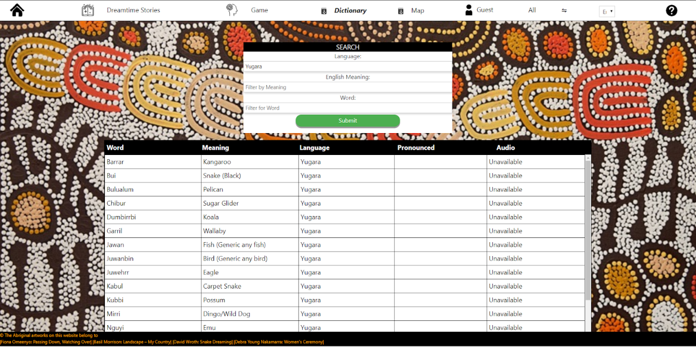

The final interactive page was the map page where users can look up where their favourite languages come from and work out what local Aboriginal people might speak. The map was implemented using a combination of OpenStreetMap, a free open source map tool for web design, and Leaflet which is a free open source library designed specifically to interact with maps like OpenStreetMap. Using these tools, the team was able to embed a map into the website with tags set up to show were specific languages come from. Due to time constraints and limited data the location data and names are simulated as opposed to dynamically generated from data in the database.

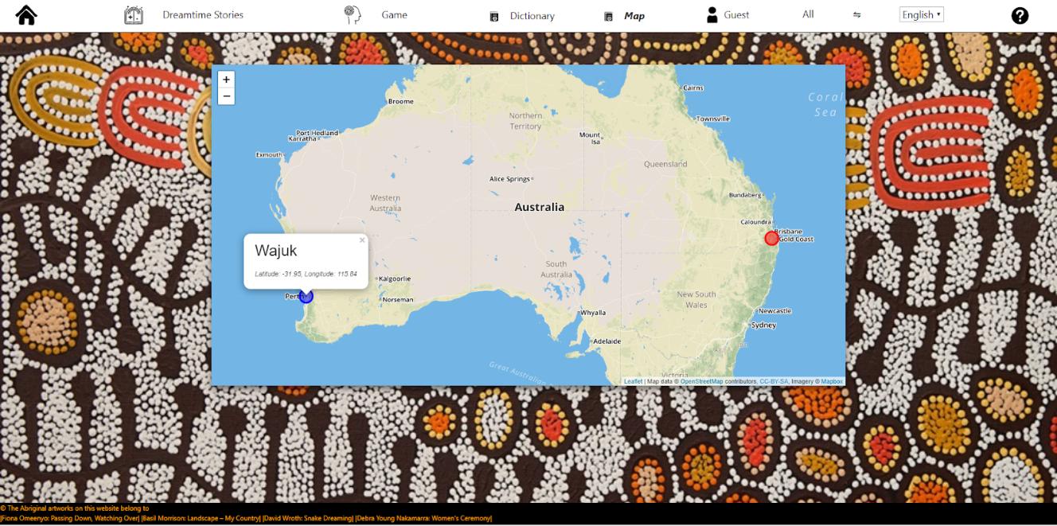

Beside the interactive pages we have a number of miscellaneous pages that complement our website. Users are given the option to sign in or sign up once they reach the website. Both of these pages use php to post data from forms and query the database to get and create users respectively. Once signed in a session is created and the username is placed in the navigation bar where users can navigate to the profile page. Users can also opt to continue as a guest if they so choose. The home page will be the next page users see once they have logged, on this page you can select an Aboriginal language to learn from a predefined list based on the database. This page uses JavaScript and CSS to create a basic animation of an Aboriginal man throwing a spear at the chosen language. Based on the chosen language the user will be redirected to the dictionary page with a filter on the chosen language, this filtering is simulated due to time constraints. Users can update their profile by navigating to the profile page (selecting their username from the navigation bar) and updating the values which are pulled into the profile page from the database using php. On this page the team has simulated profile picture uploading as we didn’t have time to set up storing images on the website. The final page is the about us page which is the question mark link at the end of the navigation bar. This is a simple page that explains who the team members are and some details about them.

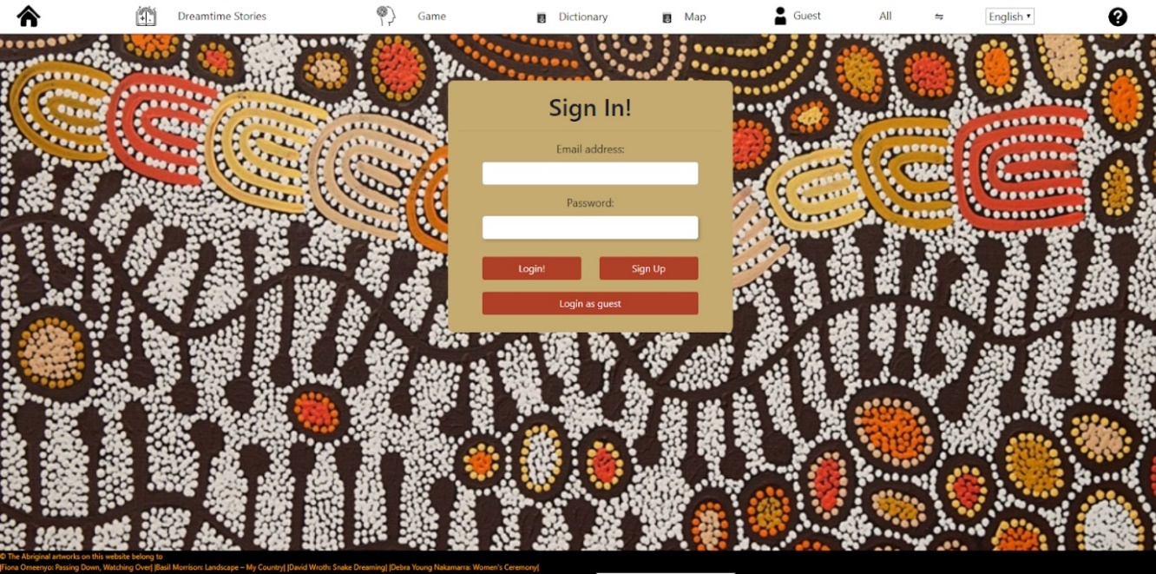

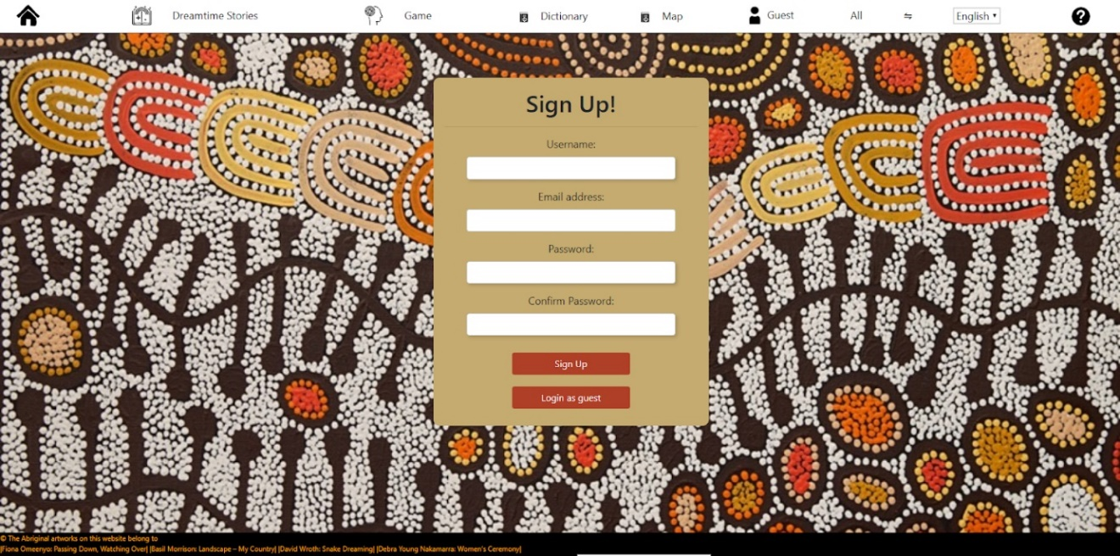

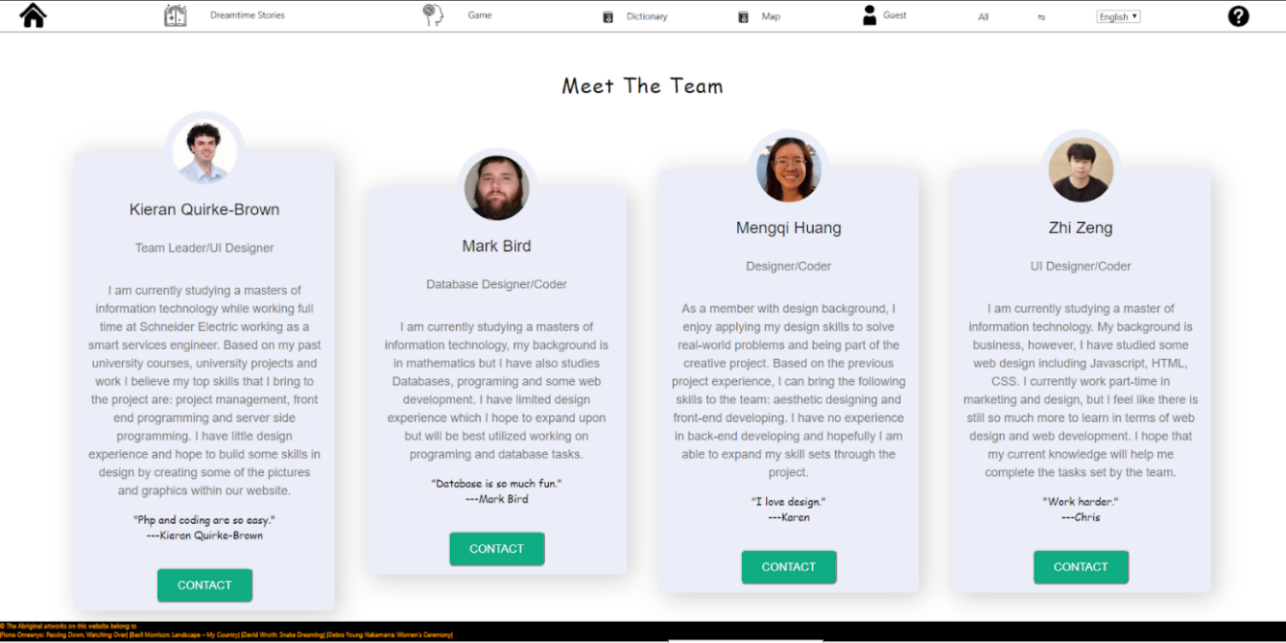

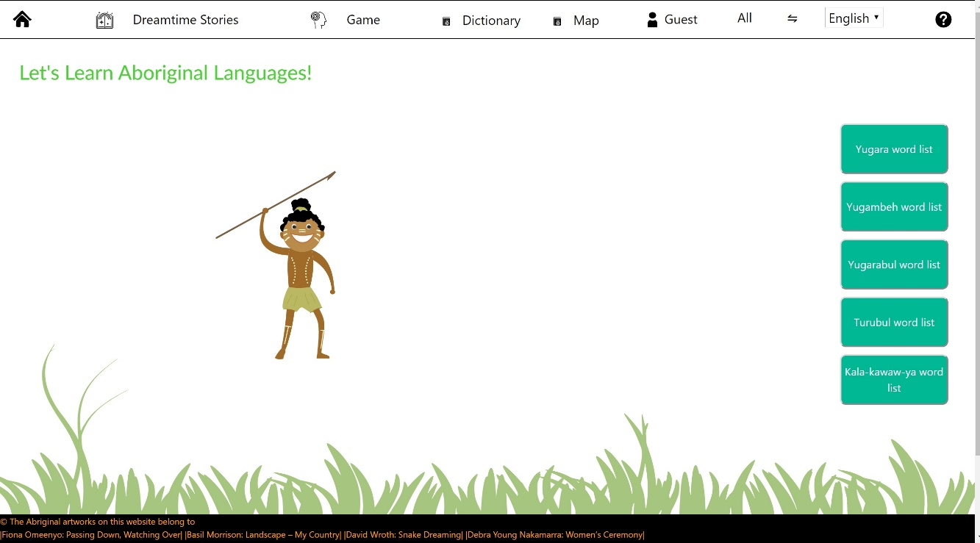

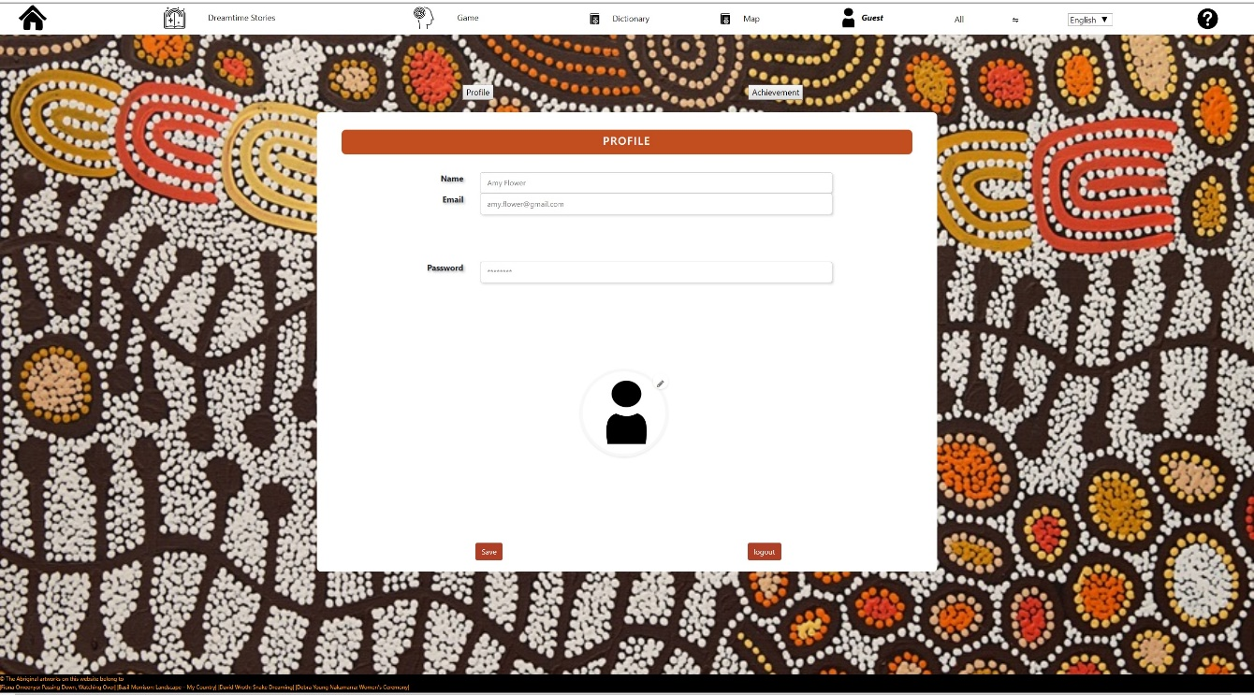

Our website can be located at the following address -<https://deco7180-c02t02.uqcloud.net/> this will take you to the sign in page where you can begin learning and interacting with Aboriginal cultures in the Brisbane area. Please note to access this website you need a zone approved UQ username and login.

Instructions:

Login:

Once you have reached the first page for the website you will be prompted to either ‘Login’, if you already have an account,  ‘Sign up’, to create a new account, or ‘Login as guest’, to get started right away. Once you have signed up/logged in you can start using the navigation bar at the top of the page to choose an activity to play. A basic test account has been set up for those who want to try logging in but don’t want to sign up, the login details are username: “test”, password: “test”.

Dreamtime Stories:

Navigate here by clicking Dreamtime Stories on the navigation bar.

click on the image with 3 circles next to a branch of a tree to go the story entry.

To turn the page hover over the top/bottom right of the page until the corner curls then left click.

As you read the story hover over the images to flip them over.

Once you come to the last page click the tree icon on the top right.

You should be back to the story entries but with an additional story.

Game:

Navigate here by clicking Game on the navigation bar.

Select the Language you wish the mystery words to be in using the Languages dropdown on the top left.

Click and Drag the Mystery Words to the box with the image you think the word represents.

If the word turns green and drops to bellow the image you were correct

If the word returns to the mystery word box, you were incorrect.

Dictionary:

You can use any combination of the filters by typing your search into the corresponding filter with blank filters being ignored by the page.

Click Submit to perform your search (the button should make a clicking animation when clicked)

If the results of the search do not fit on the page use the scroll bar or the scroll wheel on your mouse while the curser hovers over the table

We only have a limited selection of words from 4 languages currently in the database (Yugara, Yugambeh, Turubul, Yugarabul).

Leaving every filter blank and pressing select will result in a search for all words in the database.

# **Reflection on the final product**

## **Different skill sets**

Throughout this process it was apparent that the various team members had different strengths, weaknesses and skill sets. Throughout the project various team members needed help with a variety of tasks for a plethora of reasons and we feel that overall we cooperated with each other well and everyone was generally positive and helped where they could.

## **Like and dislike of the final product**

Overall, we feel that the final product demonstrates our concept and that we have achieved all our MVP milestones. we are each particularly fond and proud of the content for which we were responsible along with the project as a whole. The website contains everything we aimed for which ironically is the cause of our main dislike of the project. Because we wanted to do so many different things, we didn't have time to expand as deeply as we would like upon some of the content of the website. The Dreamtime Story section only contains two stories and the Game supports only 2 languages additionally while we planned to implement account level progression and rewards for participation in various activities, we didn't find the time to design and implement them.

## **Successful aspect vs Unsuccessful aspect**

Probably the most successful aspects of this project have been the dreamtime stories and the use of the database to dynamically pull data. The dreamtime story elegantly fulfils its purpose of engaging users in a traditional Aboriginal story whilst exposing users to snippets of the language. The flip cards were a great solution to the problem of integrating language snippets into the story and the overall aesthetic is excellent. In contrast the database was a backend aspect not visible to users but nevertheless underpins both the game and dictionary portions of the project and allows for dynamic content based on user interaction. Finally,  the About us page is a success as it does exactly what it is supposed to do and has a pleasing aesthetic

Unsuccessful aspects of the project include User Accounts, Account Progression, Language Map and the animation of the Home Page. The reason for these things being unsuccessful in the case of the User Accounts and Account Progression a lack of time for implementation as although we have a good-looking login and Account page, they have limited functionality. The language map is unsuccessful because although it is implemented, we only have 1 location marked on the map and existing sites do a better job of displaying the information. In contrast to the others the reason we consider the Home Page animation a failure is due to the amount of time invested into that aspect. None of the team members have much skill in this area and so when the member responsible had problems we could offer only limited support.

## **Improvements**

Overall if we were to continue with the project there are a number of areas that could be improved with additional work.

Database

Truthfully the database is bare bones with only a limited amount of data imported into the database, additional data is available from SLQ and would need to be imported to support some of the features mentioned below.

Audio

One of the big disappointments in our research was our inability to find any collections of audio recordings of the correct pronunciation of words in Aboriginal languages. If audio recordings could be obtained and integrated into aspects of the project such as the Dictionary, Dreamtime Stories and the Game they would greatly enhance the user experience and immersion into the story.

Game

While the game pulls data dynamically from the database depending on the language selected by the user the words will always be the names for the animals currently used in the game. to support replay ability, it would be great if the game could randomize (based on user input) which words to use in the game and pull the correct images from the database. Alternatively, the game could be made to have various levels which utilize different words from the languages available in the database.

Dreamtime Story

this section of the project could be improved by the addition of more content, while two stories more than demonstrates the concept additional stories would be needed to flesh out this aspect.

User Progression

While we feel that Account Progression could entice users to engage further with our website, we felt that other aspects where more critical and so did not prioritize the implementation of these ideas. That said we stand by our view that implementation of Account Progression and/or other gamification elements would encourage user engagement.

## Evaluation of Success

### Delivery of the MVP – Success

Comparing the Final product with the MVP outlined in the proposal shows that we have successfully implemented every element. Those elements are:

* Home page
* Word game
* Interactive Dreamtime stories
* Limited dictionaries
* User accounts

In the case of user accounts the implementation is a bit limited but it is present and during the course of the project we revaluated the need for user accounts in the MVP and moved this feature to the stretch goals.

### Delivery of Stretch goals – Limited Success

Honestly our we didn’t expect to get any of our stretch goals implemented as most of them depended on finding suitable audio resources which we failed to do. Of the remaining items we were forced to simulate achievements and implemented a map with a limited number of marked locations.

### User Interface – UNKNOWN

While we feel that great progress has been made in this area since the DEMO it is difficult to objectively evaluate our own UI. Unfortunately, we have not had time to perform additional user testing with the final product and ultimately it is users who will decide if we have succeeded in this area.

# References

|  |  |
| --- | --- |
| [1] | T. L. K. a. M. M. Grabner-Hagen, “Gamification: QUESTING TO INTEGRATE CONTENT KNOWLEDGE, LITERACY, AND 21ST-CENTURY LEARNING,” *Journal of Adolescent & Adult Literacy,* vol. 59, no. 1, pp. 51-61, 2015. |
| [2] | L.-J. W. S.-E. W. Y.-T. S. Kuo-En Chang, “Embedding game-based problem-solving phase into problem-posing system for mathematics learning,” *Computers & Education,* vol. 58, no. 2, pp. 775-786, February 2012. |
| [3] | “Duolingo,” [Online]. Available: https://www.duolingo.com/. [Accessed 11 October 2019]. |
| [4] | A. L. a. R. E. Granic, “The benefits of playing video games,” *American Psychologist,* vol. 69, no. 1, pp. 66-78, 2018. |
| [5] | C. C. S. T.-R. a. S. S. Grolig, “Effects of preschoolers’ storybook exposure and literacy environments on lower level and higher level language skills,” *Reading and Writing,* vol. 32, no. 4, pp. 1061-1084, 2018. |
| [6] | J. S.-d.-N. L. d.-M. L. F.-S. C. P. a. J. M.-H. Domínguez, “Gamifying learning experiences: Practical implications and outcomes,” *Computers & Education,* vol. 63, pp. 380-392, 2013.  Background Image of this document used with permission from Making Two Worlds Work Project which can be found at: https://www.whealth.com.au/mtww/mtww_artwork_partnerships.html |

# Appendix A - Feedback Questions

1. please rank the features in the demo in order of importance
   1. Game _____
   2. Dictionary _____
   3. Dreamtime story _____
   4. User profiles _____
   5. Home page _____
2. given the target audience is there anything you feel is missing from the project(Y/N)
   1. If yes what is missing?

1. do you feel that our project is catering to our target audience of 8-18 (Yes / No)?
   1. If no please elaborate with suggestions or constructive criticism

1. For the word game do you think our target audience would prefer
   1. Words from only 1 language at a time (i.e. mystery words from only 1 language)
   2. Words from multiple languages simultaneously (i.e. mystery words from 2+ languages)
      1. If (b) should the different languages be visually distinct or separated (i.e. different colour text)

1. For the interaction of  the storybook, what do you like the most and what needs to be improved?

1. If you are the designer, how will you design the profile page to demonstrate user account information more clearly?
2. Does the colour scheme presented make you feel like you are taking part in a new cultural experience, in what ways can this experience be improved?

1. When interacting with the application do you find the interface difficult to use or understand? Are there any improvements or suggestions you can make? Is there anything that we have done well?

1. Is there anything else you would like to tell us ?

# Appendix B - Feedback summary

Q1 average rankings

Game:                          1.5

Dictionary:                  3.25

Dreamtime Stories      3

User Profiles                  4.5

Home Page                     2.75

According to users to order of importance is:

1.       Game

2.       Home Page

3.       Dreamtime stories

4.       Dictionary

5.       User Profiles

We must keep in mind that no achievements or unlocks where available during the demo.

Q2

The only elements users identified as missing are some UI buttons for Dreamtime stories and Dictionary:

Q3.

Generally, users felt that we catered well to our audience, but some felt that we should use larger and/or more cartoon style images

Q4

Generally, users felt there was a lack of direction and feedback for the game and that only words from a single language should be present in the game at a time. Users where spoke positively about the game once they started but where uncertain how to play at the start.

Q5

Generally, users liked the flip cards where the best feature of the story and all felt that the page turning interaction needed to be clearer

Additionally, some users felt that there should be more flip cards relative to the rest of the story and that the text on the reverse of the cards should be bigger.

Q6

The feedback to this question was minimal with a suggestion for a cartoonish and colourful design being the exception

Q7

All users answered positively

Q8

All users had trouble with page turning in the story

Some users where unsure what to do in the game (instructions to small)

Several users had problems with the double click required to select a story

1 user was confused by the search form not having a search button

Q9

No feedback

Other suggestions

Make the text of the flip cards in line with other text

# Appendix C - Response to feedback

Generally, the feedback was positive but with several UI problems identified

The biggest concern is that page turning of the story was a large pain point for users along with several cases of links/buttons requiring a double click. We need a clear visual indication of how to turn the page and to focus on making other user interactions clearer along with buttons using a single click and having a visual indication that the button was pressed (small animation and/or colour change)

the game will be reworked to only contain words from a single language. Additionally, the instructions will be made more prominent give users direction. When a word is matched correctly the words colour will change so that users know the answer is correct and it would be great if we could get additional feedback when the match is incorrect as users where sometimes unsure what was going on when they made an incorrect match and the word returns to its initial position.

The background colour around the images where changed to match the colour of the storybook

Additionally, when a word is matched correctly it will change colour to provide positive feedback to the user (sound is also being considered)

Some of the icons will be resized to make the navigation bar more consistent.